CSE250 [Review]

1. Draw the alternate representations of the following circuits [Note that the number of floating sources should be minimized].
- 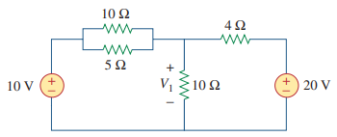
- 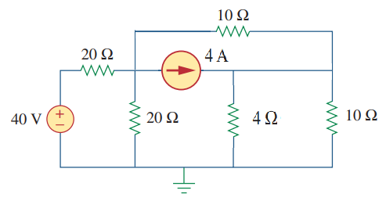

2. Find the loop representation of the following circuit:
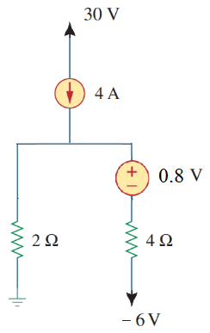

3. Here, v_{x} = (10+last digit of your ID) V

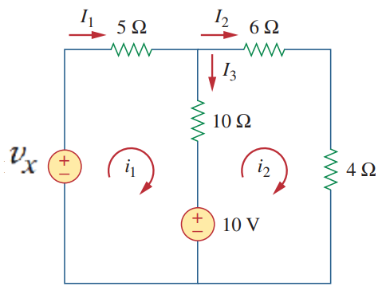
(i) Draw the alternate circuit representation of the circuit shown in the Figure above [Note that the number of floating sources should be minimized].
(ii) Apply KCL and KVL on the circuit drawn in (i) and calculate I₁, I₂, and I₃.

4.
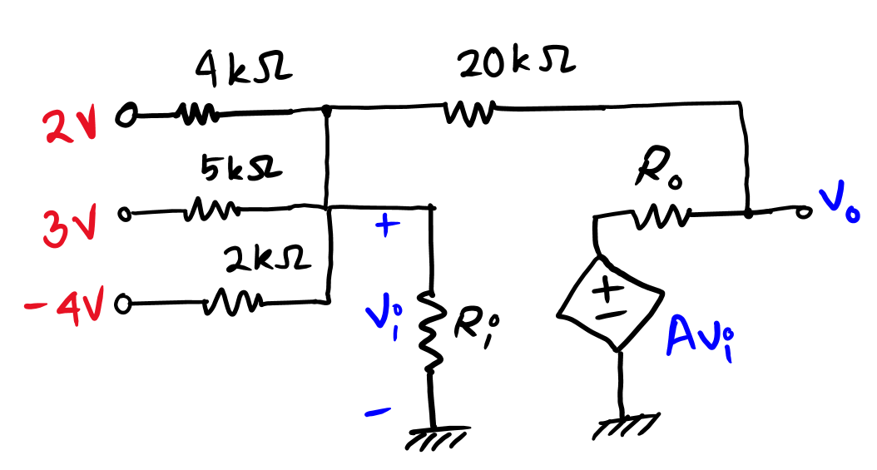
In the above circuit $A=100$, $R_{i}=100 kΩ$ and $R_{o}=1 kΩ$. Answer the following questions
- Write the node equations for the nodes indicated by $v_{i}$ and $v_{o}$. | [CO1] | 4
- Solve the node equations to find the values of $v_{i}$ and $v_{o}$. | [CO2] | 3
- Can circuit theorems based on linearity principle (such as superposition principle) be applied to the above circuit? Explain in short why or why not. | [CO1] | 3

Op-Amp

Observe the following circuit.

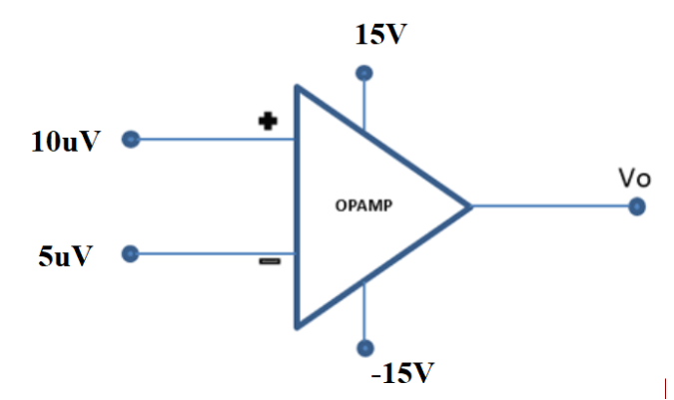
Calculate the value of Vo. Repeat the problem with V+=1 mV and V-=0.2 mV. Consider A=2105.

Draw output Vo for the following op-amp circuit.
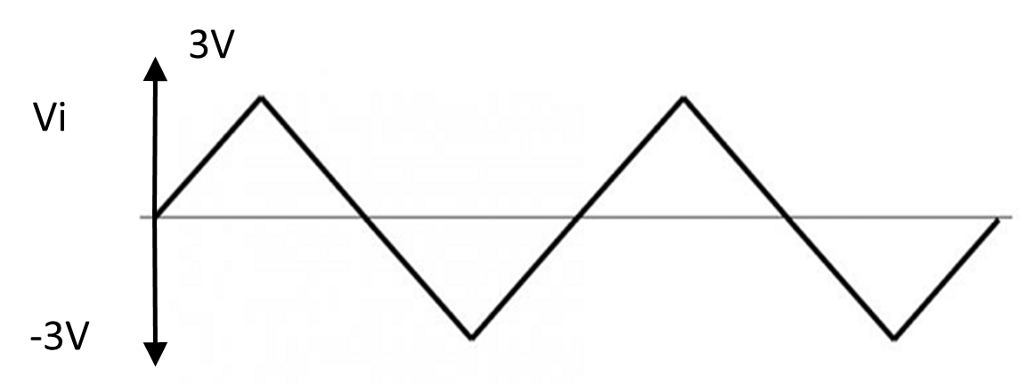
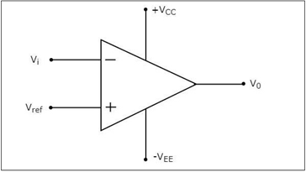
VCC = 15V= -VEE , Vref = 1.5V, Vi is a 6V p-p triangular signal as shown below.

Design a circuit using op-amp that has the voltage transfer characteristics as shown in the figure below. $v_{O}(V)$ is the output voltage and $v_{I}(V)$ is the input voltage.
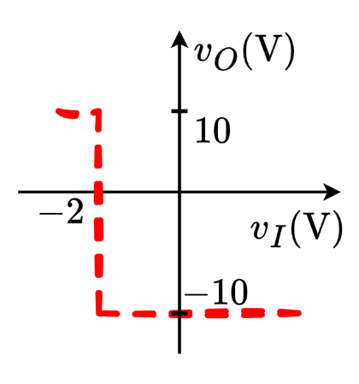

5.
A valve is used to release (when valve is OPEN,) or maintain (when valve is CLOSED,) water pressure in a water tank. The valve operates on ACTIVE LOW logic. (i.e., the valve is OPENED when given a LOW voltage of $1 V$, but remains CLOSED when provided a HIGH voltage of $6 V$.)

A pressure sensor is installed in the water tank that outputs a voltage linearly proportional to pressure, as shown in the table below.

At 0.5 atm pressure | At 1 atm pressure | At 1.5 atm pressure
$v_{ 0.5 atm}=0.5 V$ | $v_{1 atm}=3 V$ | $v_{ 1.5 atm}=5.5 V$

The pressure in the water tank can be measured by the formula $P=hρg$, where $P$, (in Pascals (Pa) unit) is the water pressure, $h$ is the height of water in the tank (in $metres$), $ρ(=1000 kgm^{-3})$ is the density of water and $g$ is the acceleration due to gravity (in $ms^{-2}$).
[1 atm = 101325 Pa]

- Design a circuit using Op-Amp comparator to automatically turn OPEN the valve if water level exceeds 10 m.
- Draw the voltage transfer characteristics (VTC) of the designed Op-Amp.

6.
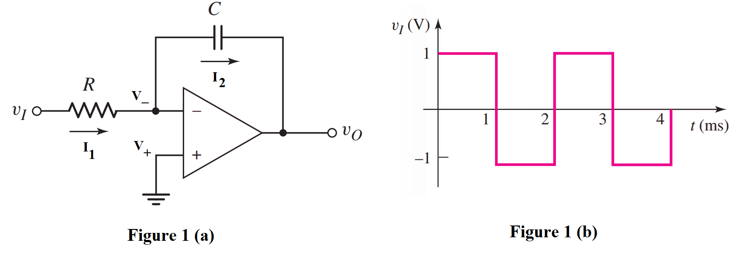
- Analyze the circuit drawn in Fig. 1(a) and determine the voltage values at the inverting and non-inverting nodes (V₋ and V₊). [0.5+0.5]
- Identify the relation between I₁ and I₂. [1]
- Analyze the circuit to derive the expression of output voltage v_{o}. You have to show all the steps. [3]
- Now consider the input wave v₁ given in Fig. 1(b). For circuit parameters R = 10 kΩ and C = 0.1μF, determine the output voltage at t = 1 ms. [1]
- Design a circuit using Op-Amps to implement the following expression: [4]
$f=\frac{1}{4}x+7y-\frac{d}{dt}z$

7.

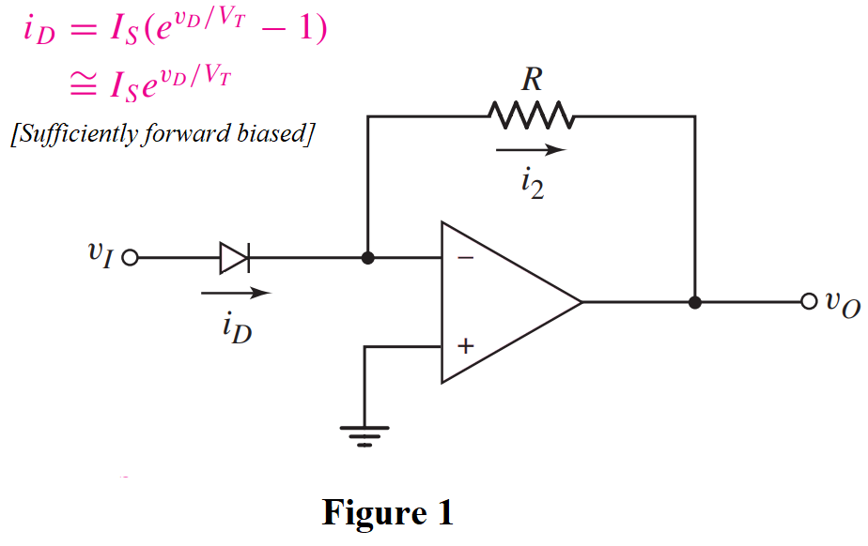
- Analyze the circuit drawn in Fig. 1 and determine the voltage values at the inverting and non-inverting nodes (V₋ and V₊). [0.5+0.5]
- Identify and briefly explain the relation between i₂ and i_{D}. [1.5]
- Analyze the circuit to derive the expression of output voltage v_{o}. You have to show all the steps. [3.5]
- Design a circuit using Op-Amps to implement the following expression: [4]

8.
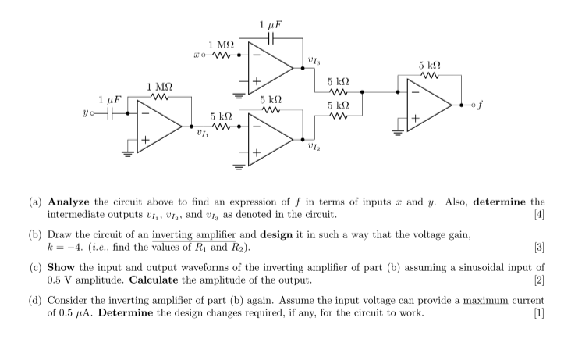

9.
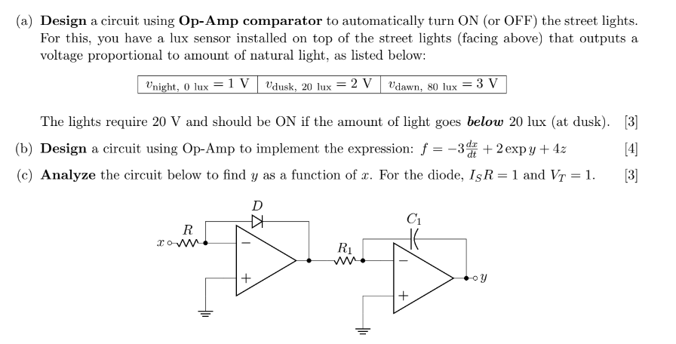

10. Deduce the expression for output, V_{o} from the circuit above
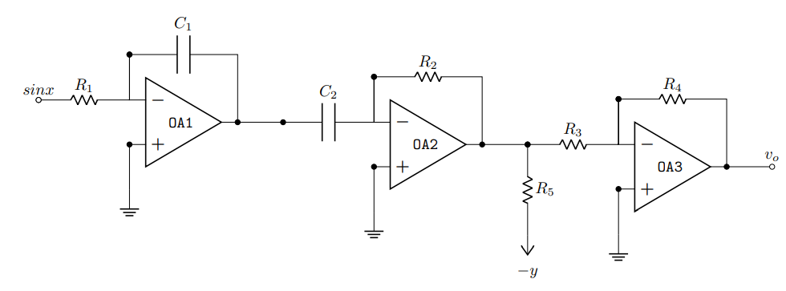

11. Design a circuit using op-amps to implement y=7x by an
- Inverting amplifier
- Non-inverting amplifier

12.

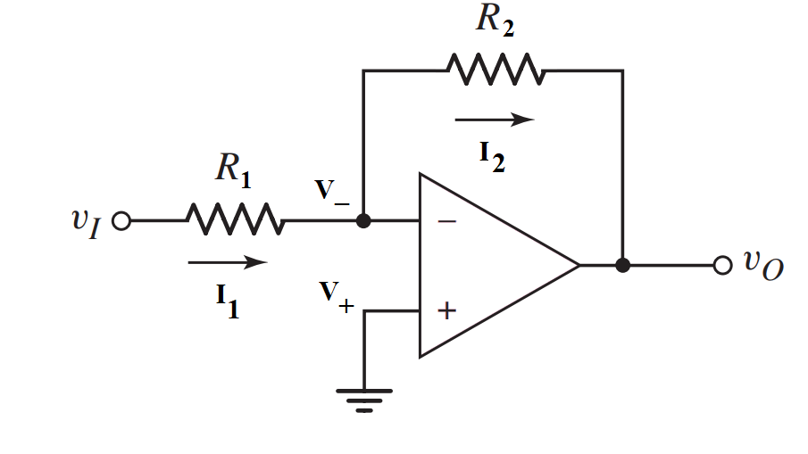

- Design an inverting amplifier (i.e., find the values of R₁ and R₂ of the circuit shown in the Figure above) in such a way that the voltage gain is −5.
- Consider the circuit you drew in (a) again. Assume the input v_{i} = 0.1 sinωt (V) has a maximum current rating of 5 μA. What design changes, if any, are required for this input, if the voltage gain remains the same?
- Draw the input and output waveforms of the circuit you designed in (c).
- Analyze the following circuit and derive the expression for the output voltage (V_{out}) in terms of the inputs. If V₁=1 V, V₂ = 2V, and V₃ = 1.5 V, and all the resistors have equal values, calculate V_{out}.
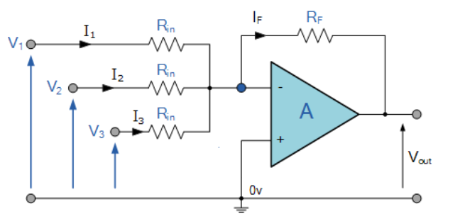

13. Analyze the following circuit to find an expression of f in terms of x, y, and z.
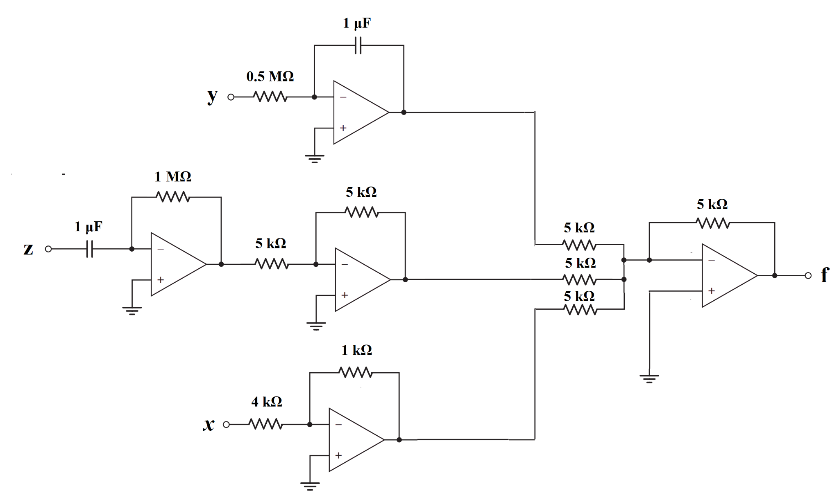

14. Consider the Ideal Op-Amp and find the value of Vo.

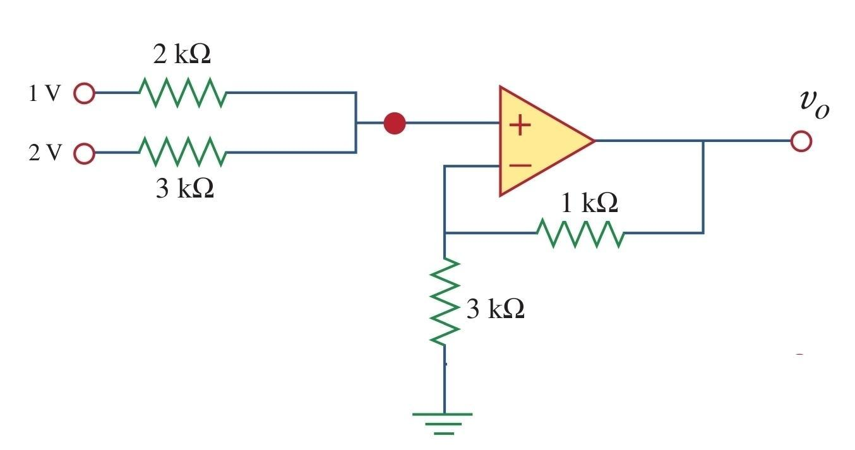

15.
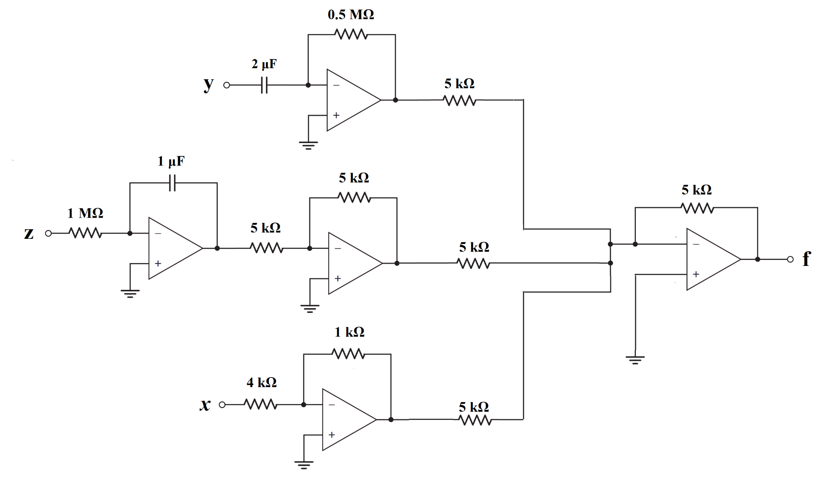
Figure 3(a) Figure 3(b)

- Analyze the circuit in Fig 3(a) to find an expression of f in terms of x, y, and z. [4]
- Design an inverting amplifier (i.e., find the values of R₁ and R₂ of the circuit shown in Fig. 3(b)) in such a way that the voltage gain is −4. [3]
- Draw the input and output waveforms of the circuit you designed in (b). [2]
- Consider the circuit in Figure 3(b) again. Assume the inpurt v_{i} = 0.1 sinωt (V) has a maximum current rating of 4 μA. What design changes, if any, is required for this input, if the voltage gain remains the same?

16.
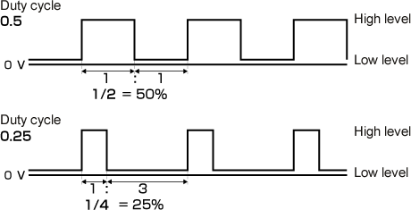
Design an op-amp circuit to transform the sinusoidal voltage, $v_{I}=5⋅sin⁡(\frac{2π}{5}⋅t)$ ($- t$ is in units of $ms$, and time-period $T$ is $5 ms$), to:
[You must evaluate $V_{REF}$]

- A square wave with a duty cycle of 50%.
- A square wave with a duty cycle of 25%.

[Duty Cycle: Time of positive half cycle $÷$ Time period]

For more information on duty cycle, click here!

[Hint: If $y=\left(θ\right)$ is a sinusoidal function with period of $2π$ then $θ=(\frac{y}{A}) and π-(\frac{y}{A})$. So, for 25% duty cycle find the value of $y$ for which $Δθ=\left(π-(\frac{y}{A}) \right)-\left(\frac{y}{A}\right) =\frac{Time period}{4}=\frac{π}{2}$ ]

17. Miscellaneous
Determine the output voltage, $v_{0}$
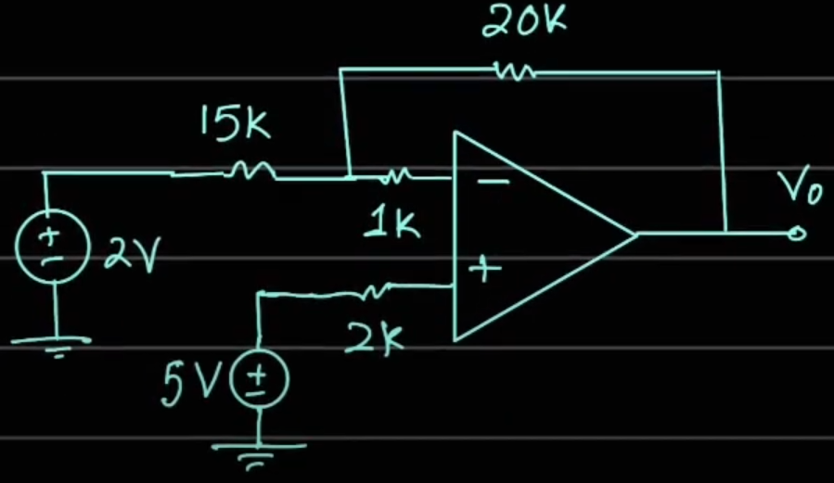

18. Miscellaneous
Determine the output voltage, $v_{0}$
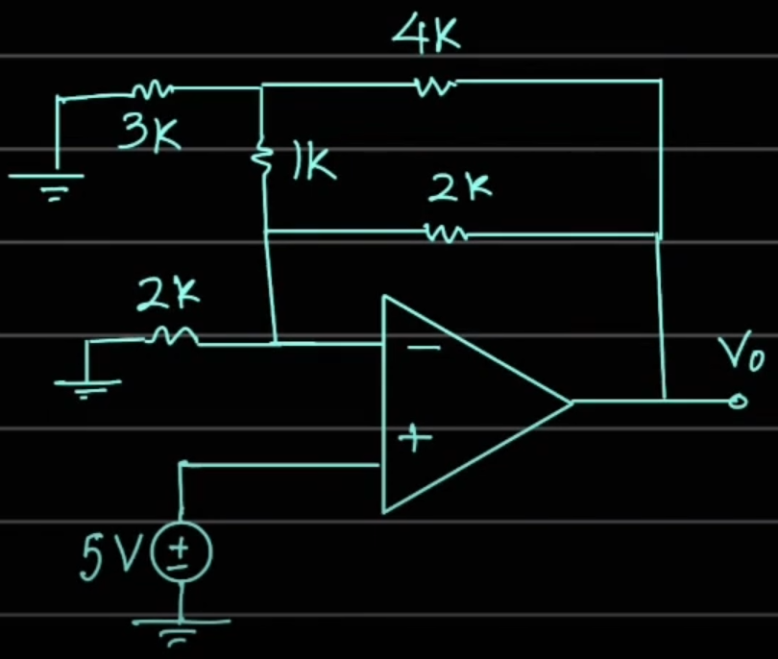

19. Miscellaneous
Determine the voltages: $V_{01}$ , $V_{X}$ , $V_{02}$
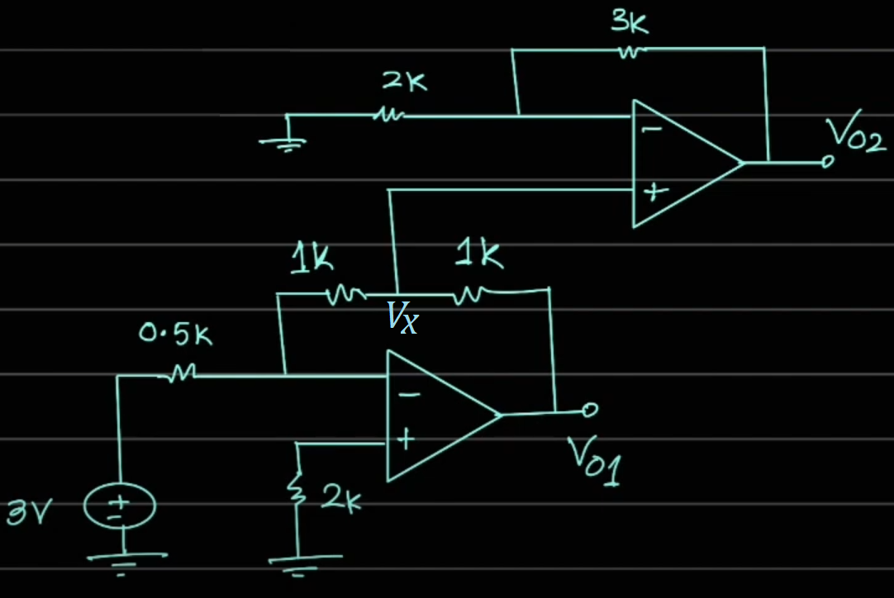

20. Miscellaneous
Determine the marked currents and the output voltage 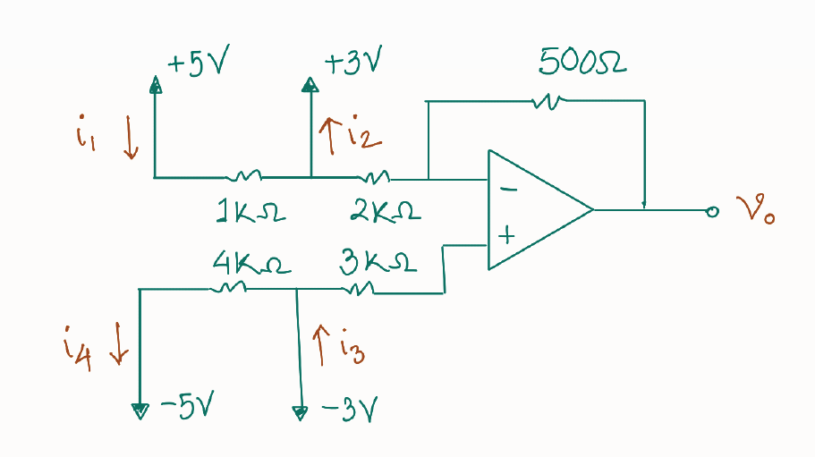

21. Miscellaneous
Determine the appropriate value of $R_{1}$

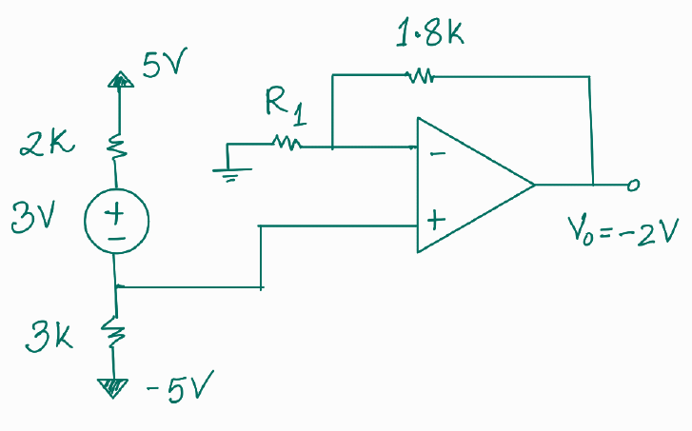

22. Miscellaneous
Express the output voltage $v_{0}$ in terms of all the other quantities shown in the circuit below.

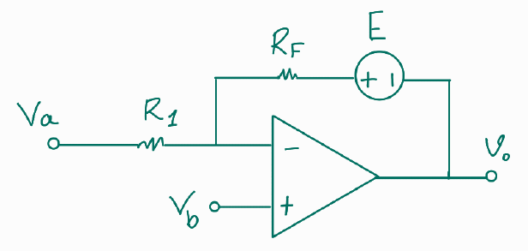

23. Miscellaneous
Determine the output of the comparator, $V_{0}$ after finding $V_{a}$ and $V_{b}$.
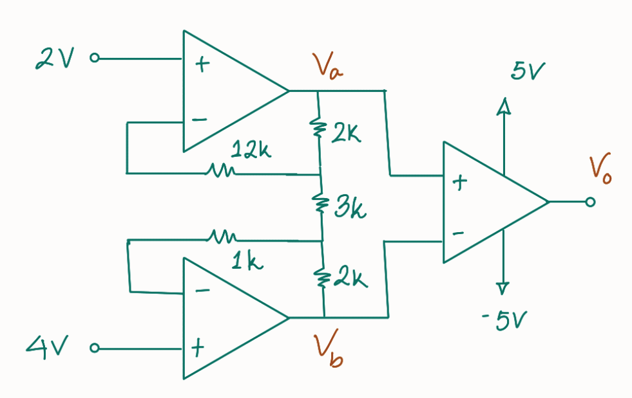

24. Miscellaneous
Draw the correct waveform of ${ V}_{0}$ (with voltage labels) alongside the input waveform of $E$ .

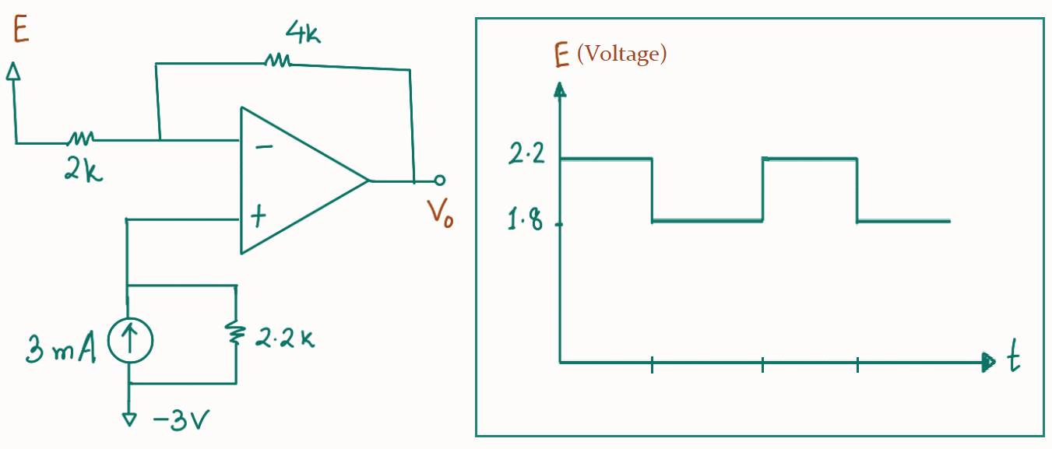

25. Miscellaneous
We know that the input-output relationship of an ideal inverting amplifier with op-amp is given by:
${ V}_{0}=$$-\frac{R_{F }}{R_{1}}{ V}_{in}$
However, realistic op-amps are non-ideal. Determine the input-output relationship of a non-ideal inverting amplifier. Use the equivalent circuit of an op-amp which contains ${ A , R}_{i} ,R_{0}.$

26. Miscellaneous
Draw the approximate waveforms of both ${ V}_{A}$ and ${ v}_{0}$ from the circuit below.

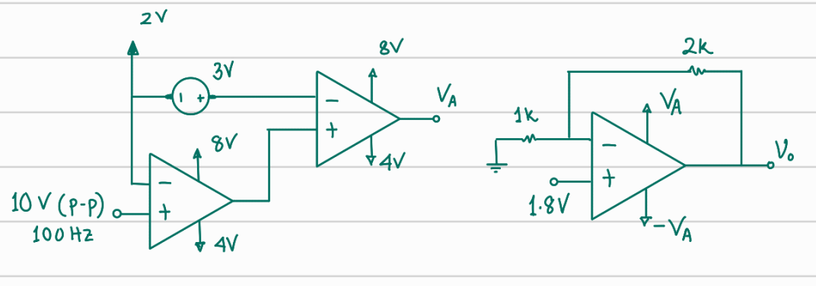

27. Miscellaneous
After drawing both $z(t)$ and $h(t)$, determine the relation between them.

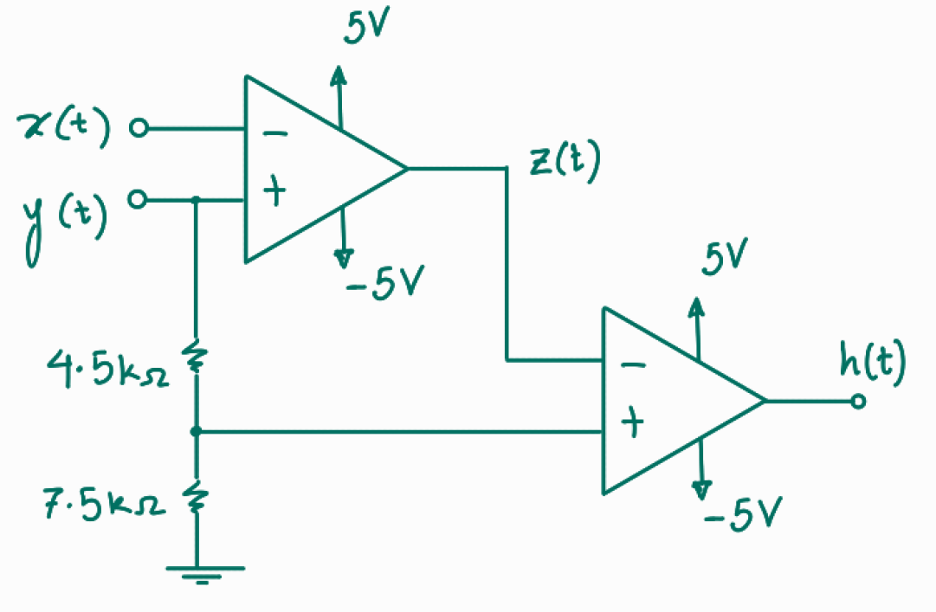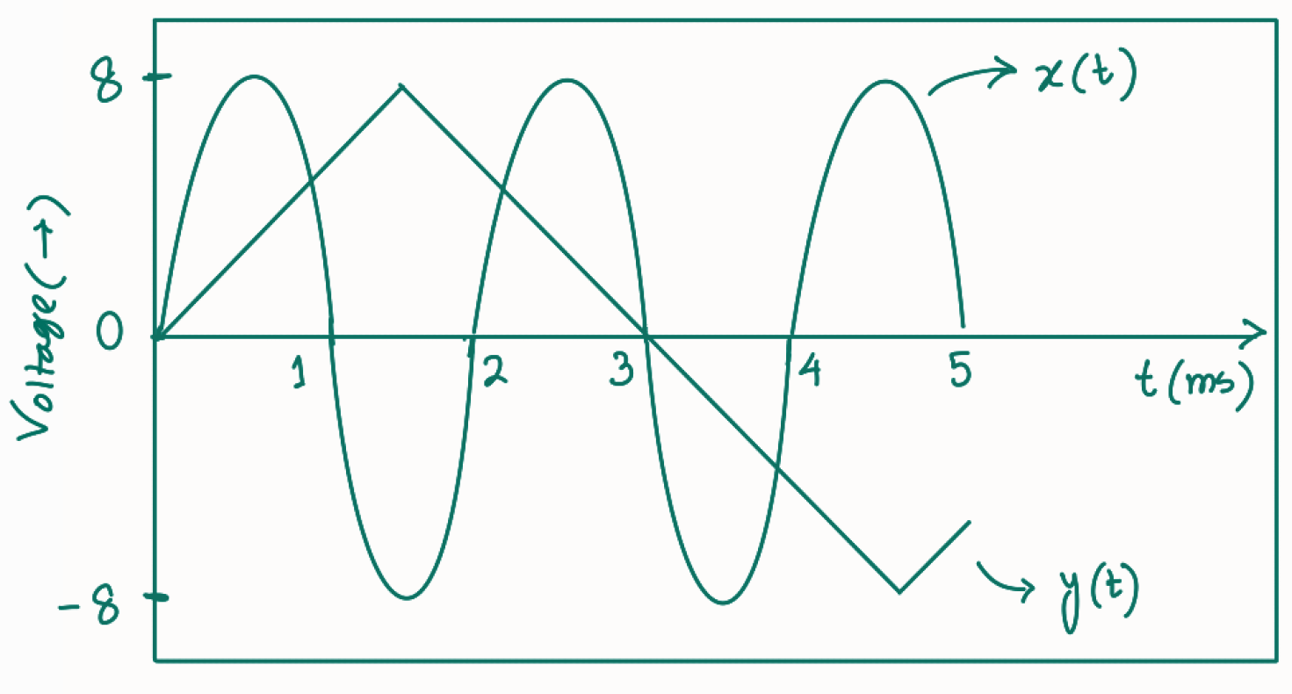

28. Miscellaneous
Draw the VTC of both an inverting and a non-inverting amplifier. The following information are known:
(i) ${2R}_{1} = R_{F}$ (ii) ${V_{sat}}^{+} = +10V, {V_{sat}}^{-} = -10V$

29. Miscellaneous
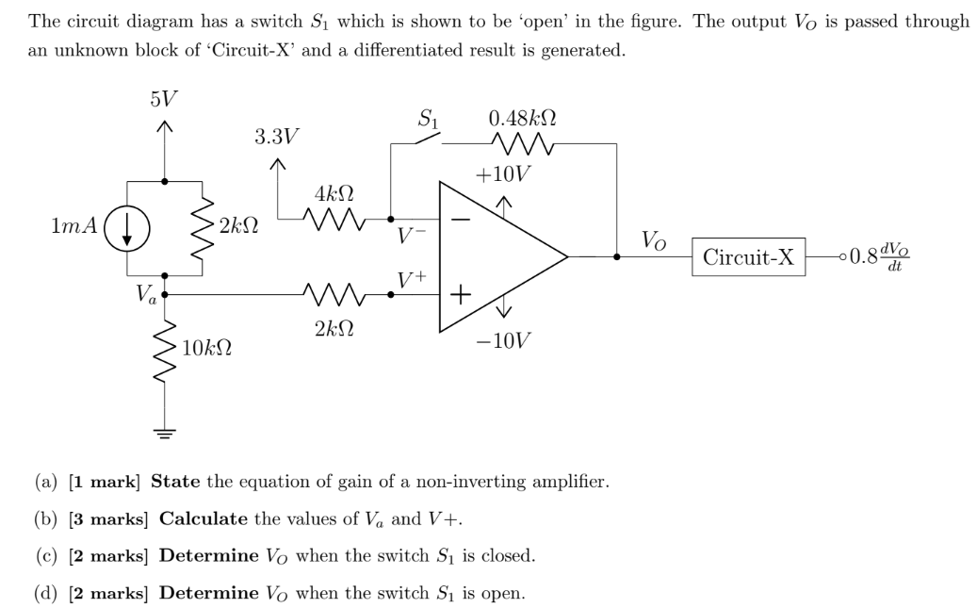

I-V

Identify which of these I-V curves are Linear and which are Nonlinear:
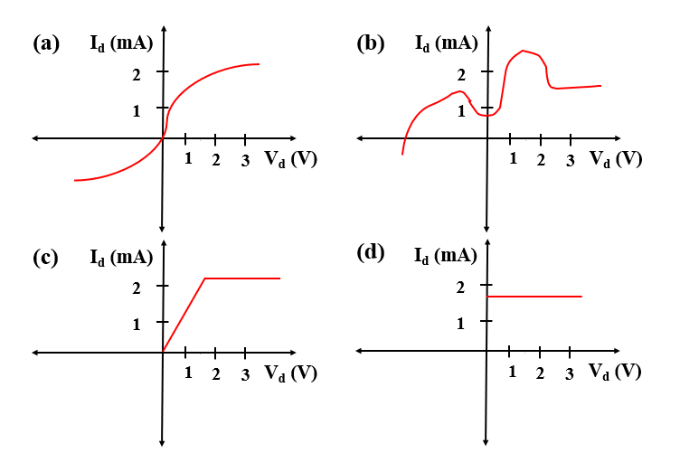
Ans: Linear: (d)

Write down the slopes of these following regions in ascending order (you do not need to calculate the slopes)
- 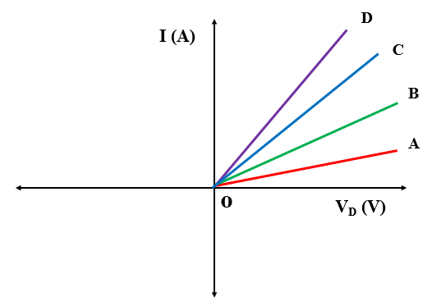(b) 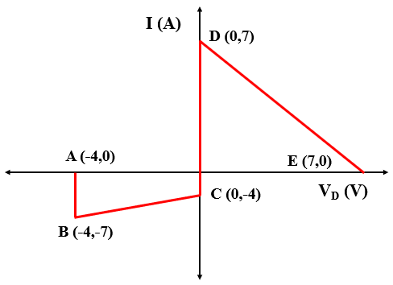
Ans: (a) |OA|<|OB|<|OC|<|OD|, (b) Slopes of AB and CD are equal(infinity). The DE slope is negative. However, the value of slope is higher than BC here. |BC|<|DE|<|AB|

Find out the slope of the following curves
Answer: Slope, |m|= $\left|\frac{y_{2}-y_{1}}{x_{2}-x_{1}}\right|$
|BC|= $\left|\frac{y_{2}-y_{1}}{x_{2}-x_{1}}\right|$= $\left|\frac{-7+4}{-4+0}\right|$= $\frac{3}{4}$
|DE|= $\left|\frac{y_{2}-y_{1}}{x_{2}-x_{1}}\right|$= $\left|\frac{0-7}{7-0}\right|$= $1$ [Can you identify the issue in this curve? ]
|AB|= $\left|\frac{y_{2}-y_{1}}{x_{2}-x_{1}}\right|$= $\left|\frac{-7-0}{-4+4}\right|$= ∞

Calculate and Show ‘C’ and ‘Io’ in the figures
[Hint: use $-\frac{Vo}{R}=Io$=c]

Draw the alternative circuit diagram, I-V curve and calculate the parameters with the following information:
i. Vo= 5V, m= 2 /$kΩ$
ii. Vo= 3.5 V, m= -2.5/$kΩ$
iii. Vo= -5V, m= 5/$kΩ$
Solution:
i. |$R$|= $|\frac{1}{m}|$ i.e. $\frac{1}{2}$ $kΩ$, $c=-\frac{Vo}{R}$= $-\frac{5}{0.5}mA=-2.5 mA$
ii. |$R$|= $|\frac{1}{m}|$ i.e. $\frac{1}{2.5}$ $kΩ$, $c=-\frac{3.5}{0.4}mA=-8.75 mA$
iii. |$R$|= $|\frac{1}{m}|$ i.e. $\frac{1}{5}$ $kΩ$, $c=-\frac{-5}{0.2}mA= 25 mA$

Alternative Diagram:
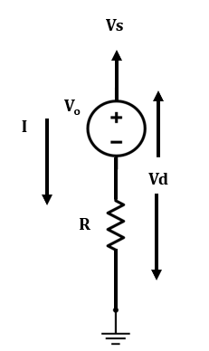
I-V curve:
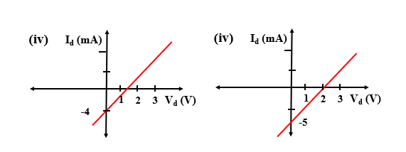

Calculate and Show ‘C’ and ‘Vo’ in the figures
[Hint: Use $IoR=-Vo$]
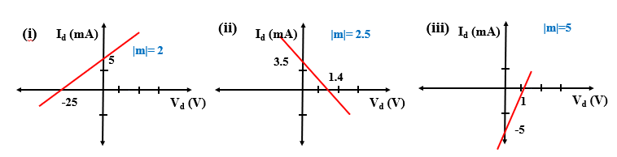

Draw the alternative circuit diagram with the equivalent linear model, I-V curve and calculate the parameters with the following information:
i. Io= 5 mA, m= 2$/kΩ$
ii. Io= 3.5 mA, m= -2.5 /$kΩ$
iii. Io= -5 mA, m= 5 /$kΩ$
Solution:
i. |$R$|= $|\frac{1}{m}|$ i.e. $\frac{1}{2}$ $kΩ$, $c=Io$= $5 mA$, $Vo=-IoR=-2.5 V$
ii. |$R$|= $|\frac{1}{m}|$ i.e. $\frac{1}{2.5}$ $kΩ$, $c=Io=3.5 mA, Vo=-(-IoR)=1.4 V$ ; as m is negative
iii. |$R$|= $|\frac{1}{m}|$ i.e. $\frac{1}{5}$ $kΩ$, $c=Io=-5 mA,Vo=-IoR=1 V$
Alternative diagram:

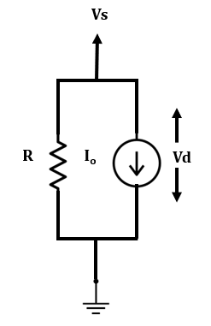
I-V:

From the I-V curve-
i. State the device model for each region,

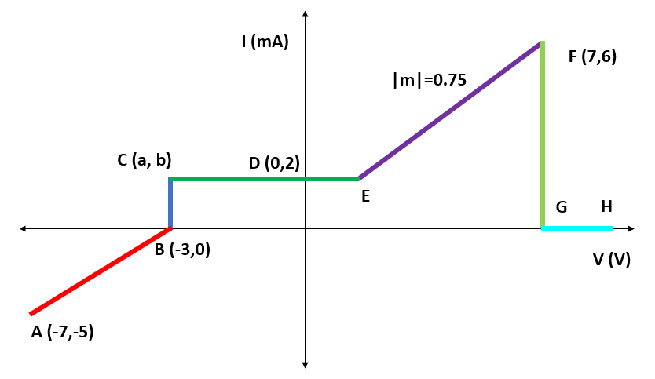

Solution:
i.
AB: Voltage source in series with a resistor/ Current source in parallel with a resistor
BC: Voltage source
CD: Current source
EF: Voltage source in series with a resistor/ Current source in parallel with a resistor
FG: Voltage source

A Voltage Source, Vo= 10 V in series with a resistor of R= 3 $kΩ$.
i. Write down the equation representing this curve
ii. Determine the unknown parameters
iii. Label the I-V curve
Solution:
i. y= mx+c
Or, I= m. Vs$-\frac{Vo}{R}$
ii. Vo= 10 V, R=3 $kΩ$
|m| $=|\frac{1}{R}|$ $=\frac{1}{3}$
Y axis intersection: c= $-\frac{Vo}{R}$= $-\frac{10V}{3kΩ}=-\frac{10}{3}$ mA
X axis intersection: $Vo$= 10 V
iii.
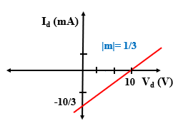

A Voltage Source, Vo= -10 V in series with a resistor of R= 3 $kΩ$.
i. Write down the equation representing this curve
ii. Determine the unknown parameters
iii. Label the I-V curve
Solution:
i. y= mx+c
Or, I= m. Vs$-\frac{Vo}{R}$
ii. Vo= 10 V, R=3 $kΩ$
|m| $=|\frac{1}{R}|$ $=\frac{1}{3}$
Y axis intersection: c= $-\frac{Vo}{R}$= $-\frac{-10V}{3kΩ}=\frac{10}{3}$ mA
X axis intersection: $Vo$= -10 V
Iii.
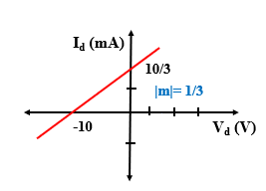

A Current Source, Io= 5 mA in parallel with a resistor of R= 5 $kΩ$.
i. Write down the equation representing this curve
ii. Determine the unknown parameters
iii. Label the I-V curve
Solution:
i. y= mx+c
Or, $Is=\frac{Vs}{R}+Io$
ii. Vo= 10 V, R=5 $kΩ$
|m| $=|\frac{1}{R}|$ $=\frac{1}{5}$
Y axis intersection : c= $Io$= 5 mA
X axis intersection: $IoR=-Vo$
Or, Vo= -5*5 V= -25V
iii.
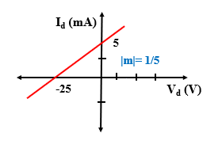

You are provided with the following circuit elements:
• Two 1 kΩ resistors
• A 4 V voltage source
• A 2 V voltage source
Can you implement a circuit element X that has an IV characteristics, as seen in the right figure below, but by ONLY USING THE ELEMENTS MENTIONED ABOVE? The voltage polarity and current direction should be as shown in the left figure.

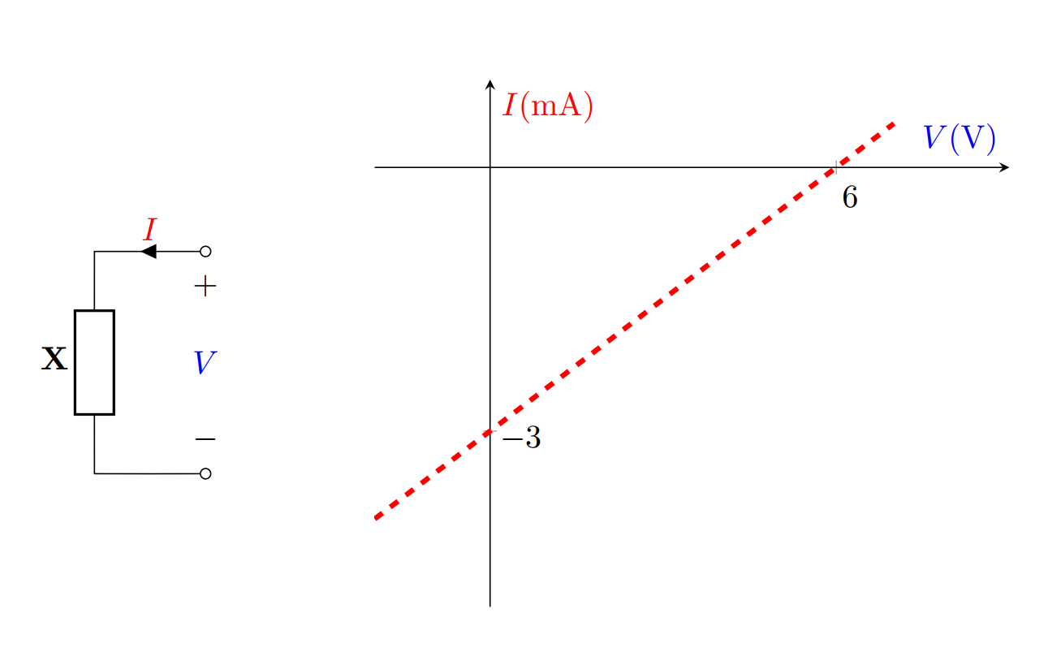

Diode Logic Gates

Assuming x, y, z are boolean variables, analyze the circuits below to find an expression of “f” in terms of x, y, and z.

i.
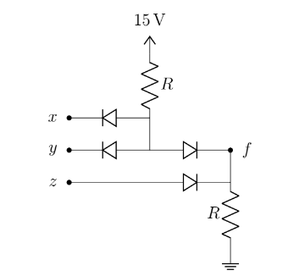

ii.
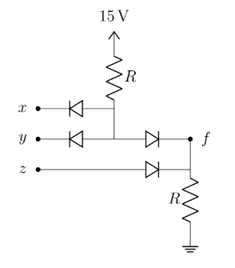

iii.
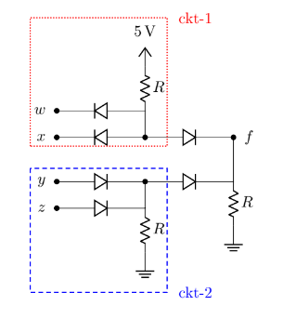

iv.
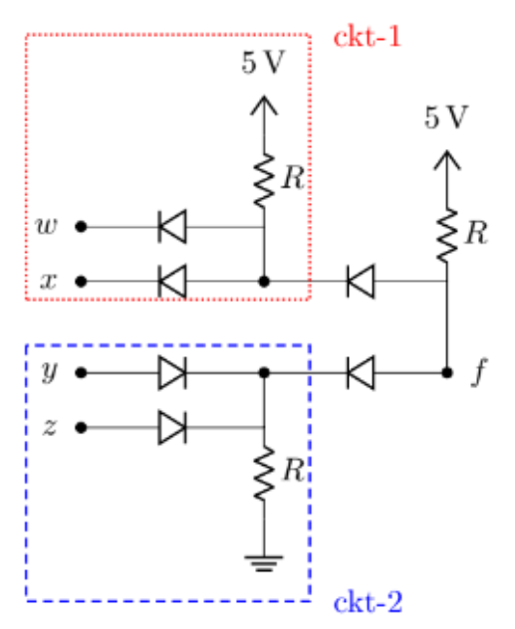

Implement the following expressions using ideal diodes:

i. xy+ yz

ii. XOR

iii. XNOR

iv. (A+B)XY

Design a 4 input AND gate using ideal diodes

Design a 3 input OR gate using ideal diodes

There will be 5 questions from 5 different topics in your exam and you will have to answer 4 out of these . You will need to fulfill the following conditions-
i. You must answer 3 questions from topic “A”, “B” and “C”
ii. You can answer one question from either “D” or “E”
Deduce the logic function using boolean variables A,B,C,D and E to implement your algorithm for choosing the questions.

For this question, assume all the diodes are ideal.
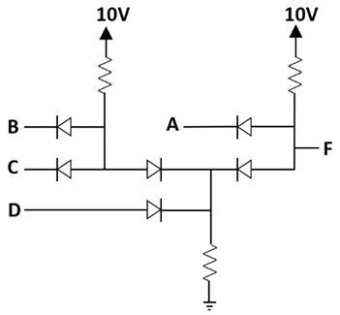
Figure 1
- Assuming A, B, C, D are boolean variables, analyze the circuit of Figure 1 to find an expression of F in terms of A, B, C and D.
- Analyze the circuit in Figure 1 to find the output voltage(s) F and complete the table in Figure 2, assuming A, B, C and D are voltage signals
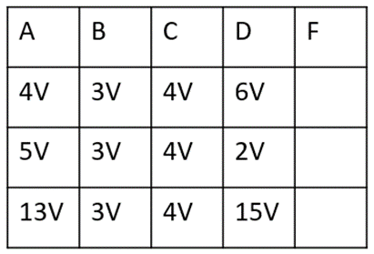
Figure 2
(c) Design a circuit using ideal diodes to implement the logic function
f = (x+y)z

Maisha is designing a game where she needs to determine an algorithm for level upgrades. The quests in level-1 are expressed using Boolean variables A, B, C, D, and E. For upgrading from level-1 to level-2 she will need to fulfill the following conditions-
i. Quest “A” and “B” must be completed
ii. At Least one quest has to be completed from “C”, “D” and “E”
(a) Deduce the logic function, F, using Boolean variables A, B, C, D, and E to implement Maisha’s algorithm. [3]
(b) Determine the values of “F” in the following table using the logic function from (a). [2]
A | B | C | D | E | F
0 | 0 | 1 | 0 | 1 | ?
0 | 1 | 1 | 1 | 0 | ?
1 | 0 | 0 | 0 | 0 | ?
1 | 1 | 1 | 0 | 0 | ?

(c) Draw the circuit diagram implementing the logic function from (a). [3]
(d) Discuss whether you can design a NAND gate with Si diodes. [2]

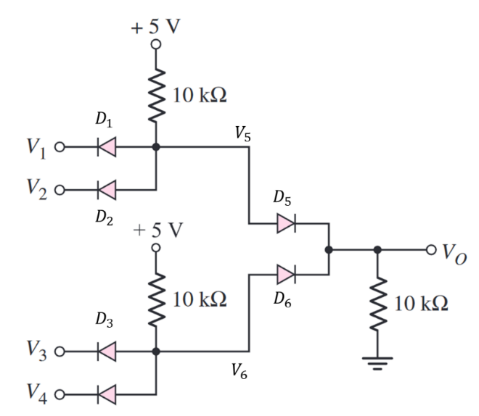
In the adjacent figure we have the following parameters:
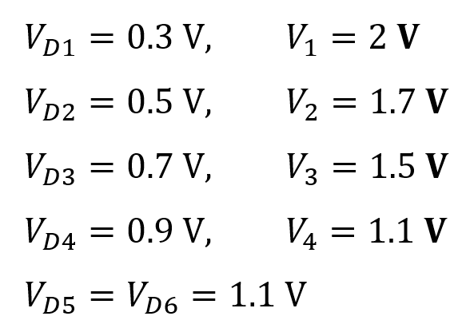

- Find $V_{5}$ and $V_{6}$. [5]
- Find $V_{O}$. [5]
- [BONUS – 5 Marks]: Solve the circuit to get $V_{O}$ when $V_{1}=7 V, V_{2}=8 V$ and all other parameters remain the same.

Diode: Method of assumed states
For the following circuits (a) Analyze the following circuit to find the values of $I_{D1}$,$I_{D2}$,$V_{X}$, and $V_{Y}$. Here, use the Method of Assumed State using the CVD model of diode with $V_{D0}$= 0.3 V. (b) Validate your assumptions about the states of the diodes.

1.
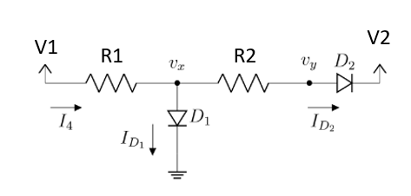
i. V1= 10 V, V2= -10 V, R1= 10 K, R2= 20K
ii. V1= -5 V, V2= 20 V, R1= 10 K, R2= 20K

2.
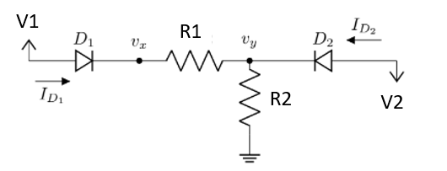
i. V1= 5 V, V2= -3.5 V, R1= 1 K, R2= 10K
ii. V1= 5 V, V2= -3.5 V, R1= 10 K, R2= 10K

3.

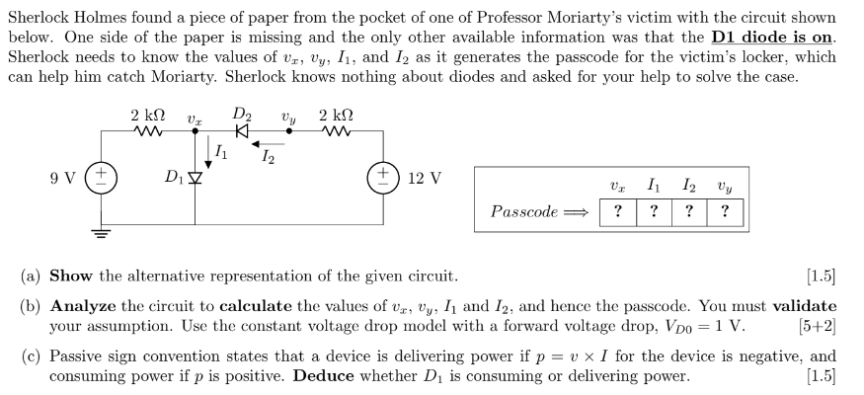
4.

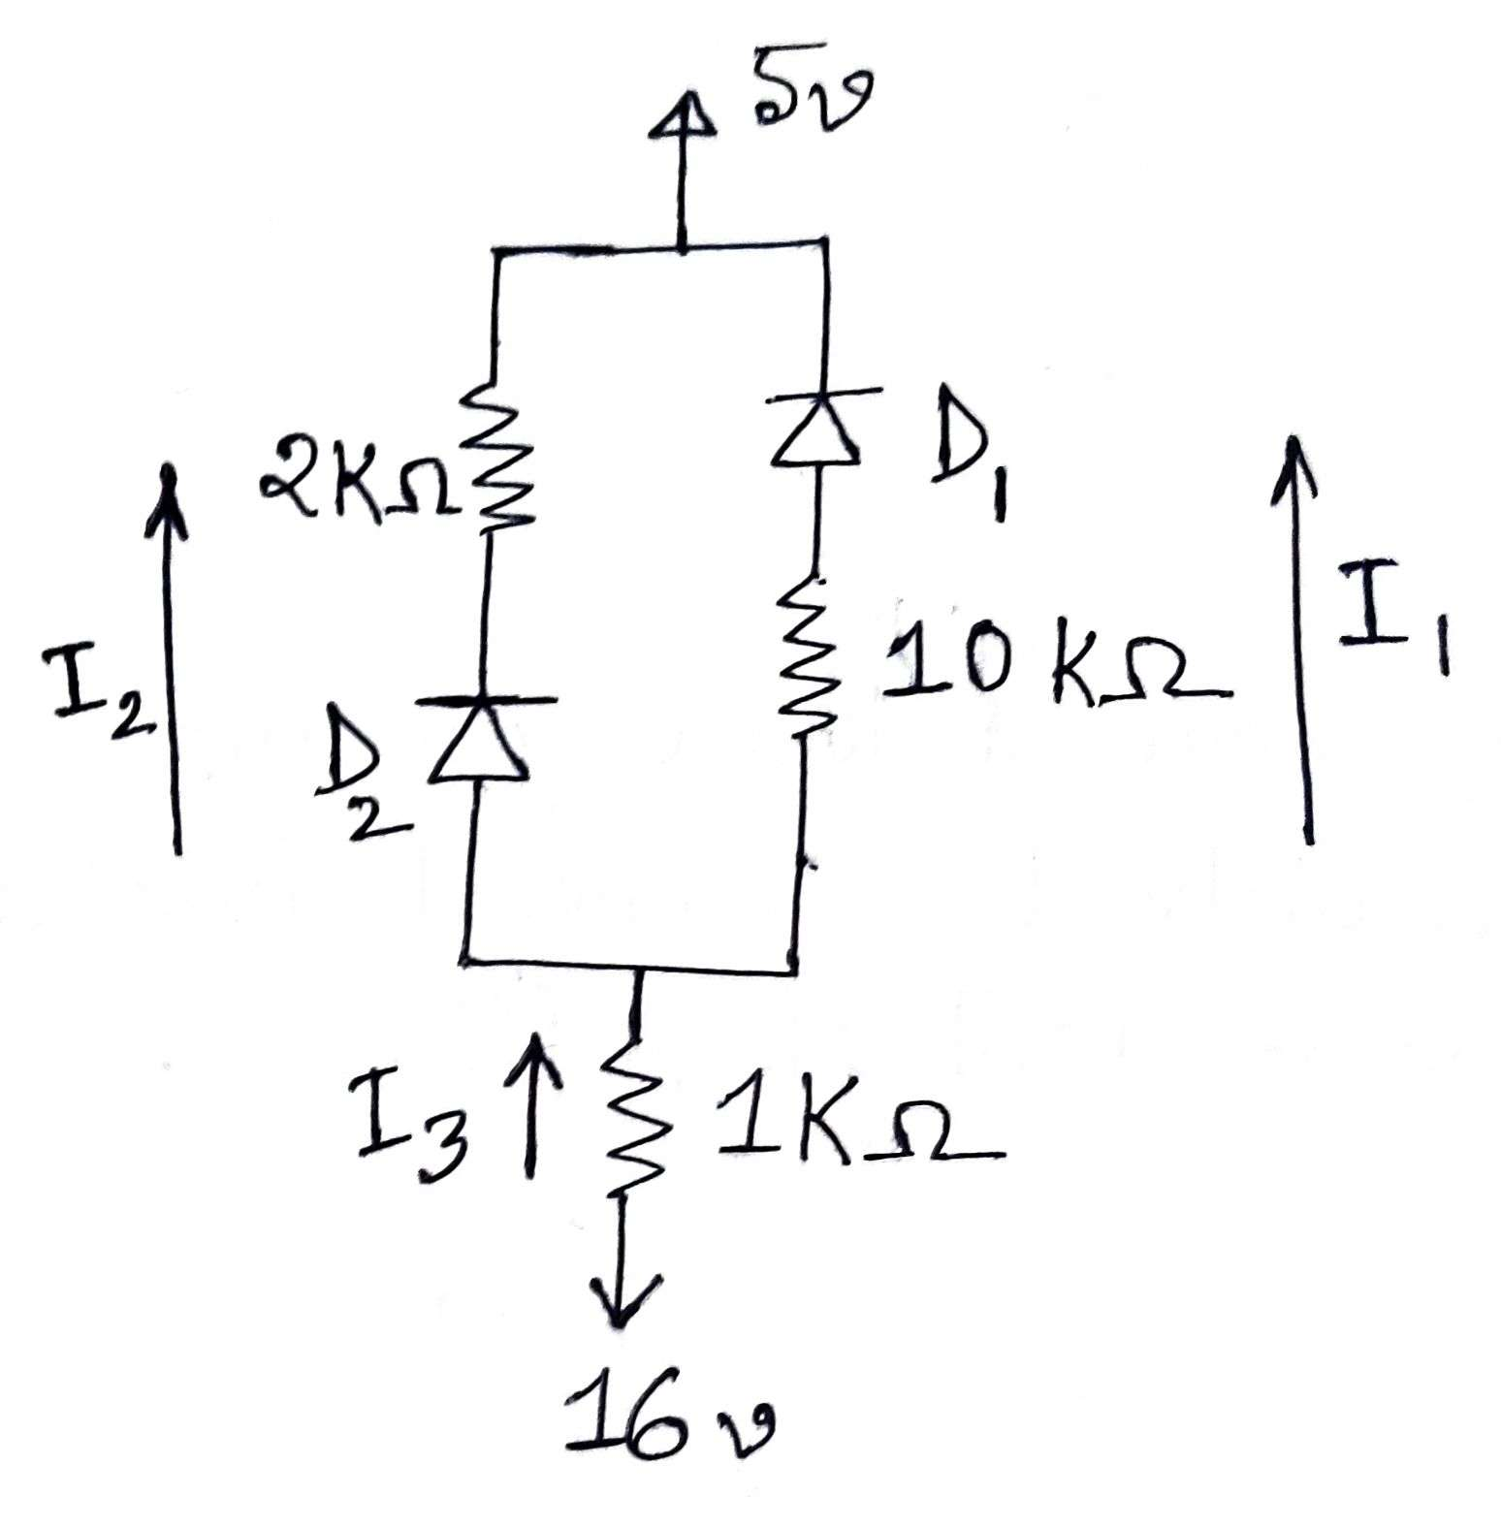
Analyze the circuit given above. Calculate the values of I₁, I₂, I₃. You must validate your assumptions. Use the Constant-Voltage Drop model(CVD Model) with V_{D0} = 0.8 V.

5.
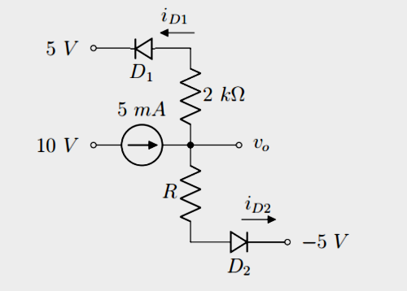
Find Vo, i_{D1} and i_{D2} for R = 1 kΩ. Assume diode constant voltage drop model with Vdo = 0.7v . In each case, write down the states of the diodes (ON/OFF). You must verify your assumptions.

6.

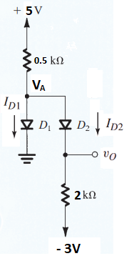
Analyze the following circuit. Calculate the values of V_{A}, V₀, I_{D1}, and I_{D2}. You must validate your assumptions. Use the Constant-Voltage Drop model with a cut in voltage of 0.6V [V_{D0} = 0.6 V]. [Hints: You may start with calculating the voltage values first]

- Please find some other examples here: Week 4 (Method of Assumed State Examples).pdf

7.
The switches S1 and S2 are shown in open configuration below.
Assume, $V_{D0}= 0.7V$ (CVD model)
(i) Find the current passing through the $100k$Ω resistor when only S1 is closed.
(ii) Find the current passing through the $100k$Ω resistor when only S2 is closed.

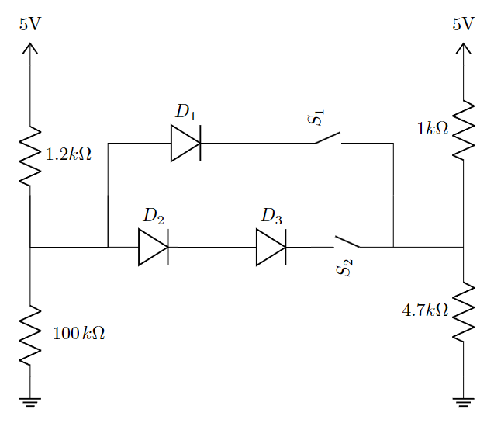

Rectifiers

1.
The input of a full-wave rectifier is a cosine voltage with peak $V_{M}$ = 5 V and frequency 60 Hz, and output load resistance is R = 2 kΩ. Silicon diodes are used in this circuit for which the forward drop is $V_{D0}$ = 0.7 V.
(a) Briefly explain the purpose of a rectifier and describe its operation.
(b) Show the input and output waveforms.
(c) Calculate the DC value of the output voltage.
Now after connecting a capacitor in parallel with the load, the output becomes a ripple voltage Vout = $V_{DC}$ ±0.2 V
(d) Calculate the peak-to-peak ripple voltage, and from that, the value of the capacitor.
(e) Calculate the average of the output voltage $V_{DC}$ after connecting the capacitor. Compare this with the DC value determined in ‘c’ and comment on the difference between these two.

2.
The input of a Half-wave rectifier is a sine voltage with peak VM = 10 V and frequency 55 Hz, and output load resistance is R = 2.5 kΩ. Silicon diodes are used in this circuit for which the forward drop is $V_{D0}$ = 0.4 V.
(a) Calculate the DC value of the output voltage.
Now after connecting a capacitor in parallel with the load, the output becomes a ripple voltage Vout = $V_{DC}$ ±0 V.
(d) Calculate the peak-to-peak ripple voltage, and from that, the value of the capacitor.
(e) Calculate the average of the output voltage $V_{DC}$ after connecting the capacitor. Compare this with the DC value determined in ‘c’ and comment on the difference between these two.
(f) Draw the Voltage Transfer Characteristic (VTC) curve
(g) What is the frequency of the Ripple voltage?

3.
The input of a full-wave rectifier is expressed by, Vs(t)= 7sin(400πt), and output load resistance is R = 5 kΩ. Silicon diodes are used in this circuit for which the forward drop is $V_{D0}$ = 0.3 V.

(a) Calculate the input and output wave frequency.
(b) Show the input and output waveforms.
(c) Calculate the DC value of the output voltage.

Now after connecting a capacitor, C= 100 µF in parallel with the load.

(d) Calculate the peak-to-peak ripple voltage,
(e) Calculate the average of the output voltage $V_{DC}$after connecting the capacitor. Compare this with the DC value determined in ‘c’ and comment on the difference between these two.
(f) How can you provide better filtering for the output waves?
(g) What is the frequency of the Ripple voltage?

4.
The input of a Half-wave rectifier is a Square wave voltage with peak $V_{M}$= 15 V and frequency 0.5 Hz, and output load resistance is R = 5 kΩ. Silicon diodes are used in this circuit for which the forward drop is $V_{D0}$ = 0.7 V.
i. Show the input and output waveforms.
ii. Draw the VTC curve

5.
The input of a full-wave rectifier is a Square wave voltage with peak $V_{M}$= 15 V and frequency 0.5 Hz, and output load resistance is R = 5 kΩ. Silicon diodes are used in this circuit for which the forward drop is $V_{D0}$ = 0.7 V.
i. Show the input and output waveforms.
ii. Draw the VTC curve

6.
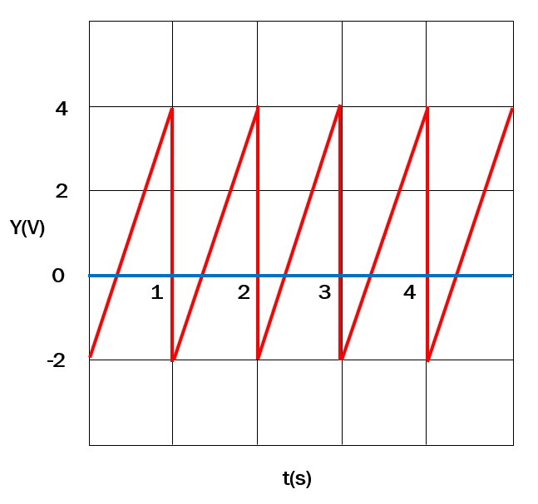
The input of a Half-wave rectifier is exhibited in the Figure above and output load resistance is R = 5 kΩ. Silicon diodes are used in this circuit for which the forward drop is $V_{D0}$ = 0.7 V.
i. Show the input and output waveforms.
ii. Draw the VTC curve

7.
A full-wave rectifier is designed to deliver a maximum current I_{L} = 120 mA to the load. The rectifier produces an output with a ripple of 5% of the peak output voltage. An input line voltage of 120 V (peak), 50 Hz is available. A 10:1 step-down transformer is used to transform the supply voltage to 12 V (peak).
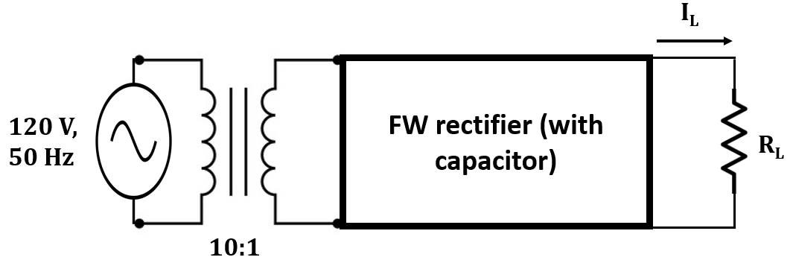
- Draw the Voltage Transfer Characteristics of the full-wave rectifier. [2]
- Calculate the peak output voltage. [1]
- Determine the value of the Load Resistor to deliver a maximum load current of 120mA. [2]
- Deduce the value of the Capacitor and the DC average value. [1]
- Assume the transformer is removed and the rectifier is directly connected to the AC power supply line. Discuss the state of the diodes. [ Hint: use the Peak Input Value of the rectifier input] [3]

Hybrid Problems [Diode, OP-AMP]

1.
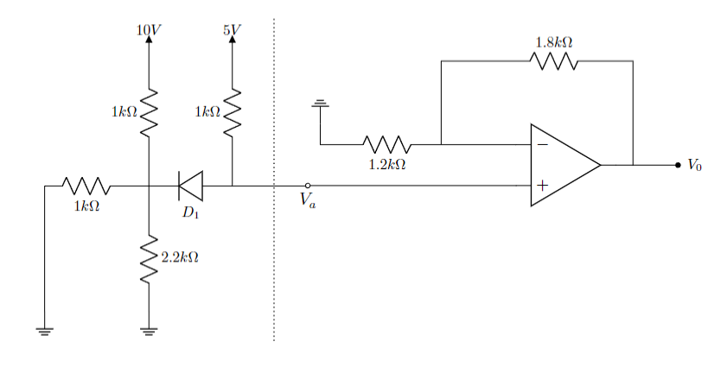

The saturation voltages of the Op-Amp are given as- $V_{sat}^{+}=+10V$ and $V_{sat}^{-}=-10V$. The forward voltage drop of the diode, $V_{D}$ is $0.7V$.
(a) Determine the operating mode diode, $D_{1}$. Verify your assumption with necessary calculations.
(b) Calculate the voltage at - (i) node ‘Va’, (ii) non-inverting terminal of the Op-Amp, (iii) inverting terminal of the Op-Amp.
(c) Find out the output voltage, Vo of the Op-Amp.
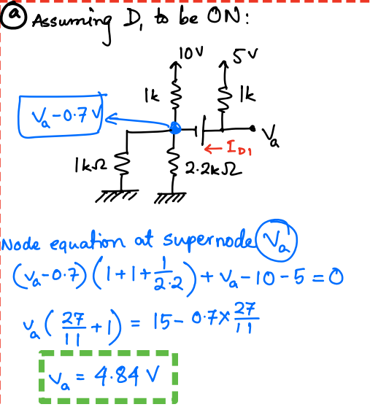
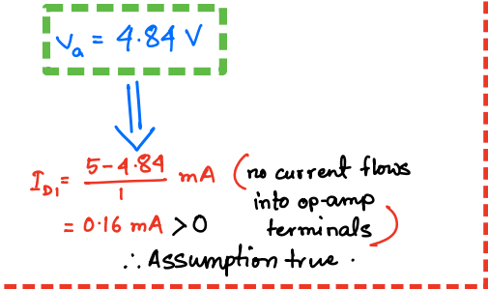

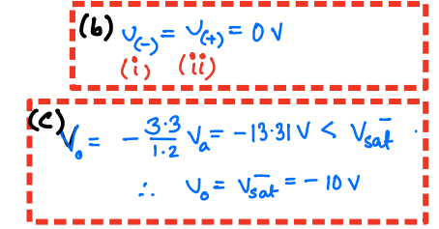

2.
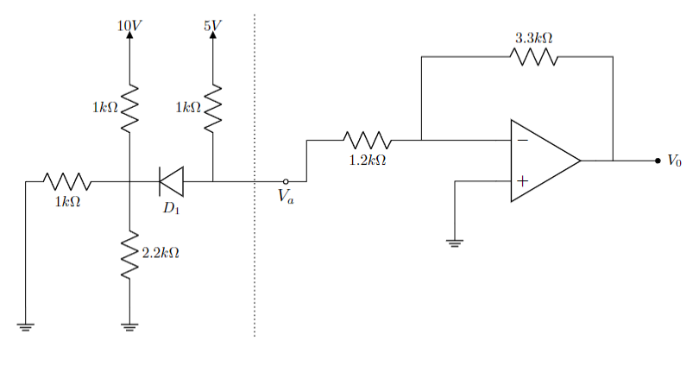
The saturation voltages of the Op-Amp are given as- $V_{sat}^{+}=+10V$ and $V_{sat}^{-}=-10V$. The forward voltage drop of the diode, $V_{D}$ is $0.7V$.
(a) Determine the operating mode diode, $D_{1}$. Verify your assumption with necessary calculations.
(b) Calculate the voltage at - (i) node ‘Va’, (ii) non-inverting terminal of the Op-Amp, (iii) inverting terminal of the Op-Amp.
(c) Find out the output voltage, Vo of the Op-Amp.

3.
You are provided with the diagram below as a starting point for designing an AC to DC converter. Input voltage source is an sinusoidal voltage source ($V_{in}$), with 6V peak to peak voltage (i.e. 3 V amplitude) and the DC voltage is around 10 V (with ripple) at the output terminals ($v_{o}$).
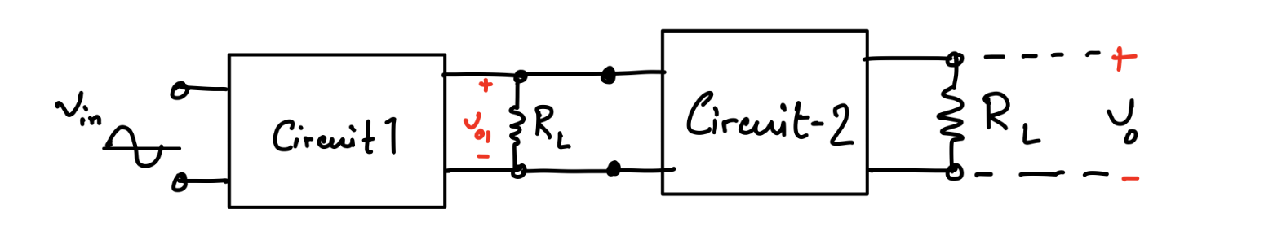
So, in order to solve this problem, you are provided with a single diode (with $V_{D0}=0.7$ V), two resistors ($R_{1}$ and $R_{2}$, excluding the load resistors $R_{L}$) and an UA741 op-amp.

- Design circuit-1 with the single diode and $R_{L}= 10 kΩ$ ($R_{L}$is already provided in the diagram as output terminals of circuit-1) to get a rectified voltage and determine the DC value of the output voltage ($v_{o1}$) of the circuit. [1+2]
- Determine the ripple voltage of $v_{o1}$. [Ripple voltage is defined as the difference between the maximum and minimum value of a DC voltage.] [2]
- What should be the value of a capacitor used at the output end of circuit-1 with $R_{L}$ to reduce the ripple voltage of $v_{o1}$ to 0.$1 V$. How should the capacitor be connected with $R_{L}$ in the diagram? [4+1]
- Design an amplifier using an operational amplifier as circuit-2 to increase the DC voltage level of the output voltage of the circuit designed in (c) to 10 V. Find the ripple voltage of the amplified voltage signal. [4+1]

4. 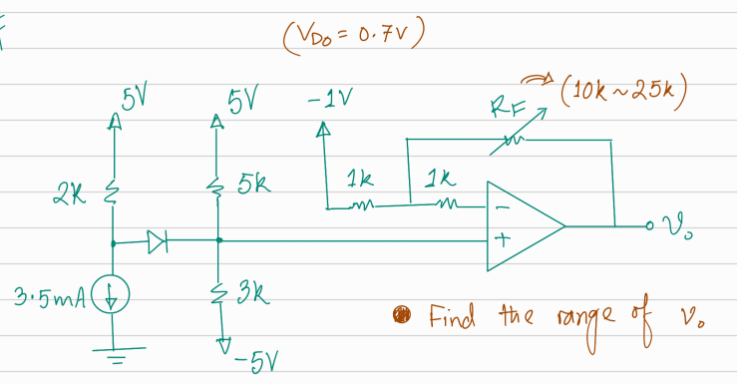

5.

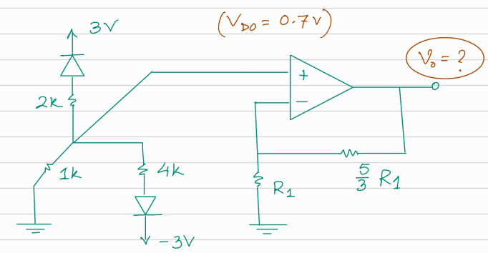

Rectifiers
- The input of a full-wave rectifier is a cosine voltage with peak $V_{M}$ = 5 V and frequency 60 Hz, and output load resistance is R = 2 kΩ. Silicon diodes are used in this circuit for which the forward drop is $V_{D0}$ = 0.7 V.
(a) Briefly explain the purpose of a rectifier and describe its operation. [1]
(b) Show the input and output waveforms. [2]
(c) Calculate the DC value of the output voltage. [1]
Now after connecting a capacitor in parallel with the load, the output becomes a ripple voltage Vout = $V_{DC}$ ±0.2 V
(d) Calculate the peak-to-peak ripple voltage, and from that, the value of the capacitor. [2]
(e) Calculate the average of the output voltage $V_{DC}$ after connecting the capacitor. Compare this with the DC value determined in ‘c’ and comment on the difference between these two. [2]

- The input of a Half-wave rectifier is a sine voltage with peak VM = 10 V and frequency 55 Hz, and output load resistance is R = 2.5 kΩ. Silicon diodes are used in this circuit for which the forward drop is $V_{D0}$ = 0.4 V.
(a) Calculate the DC value of the output voltage. [1]
Now after connecting a capacitor in parallel with the load, the output becomes a ripple voltage Vout = $V_{DC}$ ±0.3 V.
(b) Calculate the peak-to-peak ripple voltage, and from that, the value of the capacitor. [2]
(c) Draw the Voltage Transfer Characteristic (VTC) curve [2]

- The input of a full-wave rectifier is expressed by, Vs(t)= 7sin(400πt), and output load resistance is R = 5 kΩ. Silicon diodes are used in this circuit for which the forward drop is $V_{D0}$ = 0.3 V.

(a) Calculate the input and output wave frequency. [2]
(b) Show the input and output waveforms.
Now after connecting a capacitor, C= 100 µF in parallel with the load.
(c) Calculate the peak-to-peak ripple voltage,
(d) How can you provide better filtering for the output waves?
(e) What is the frequency of the Ripple voltage?

- The input of a Half-wave rectifier is a Square wave voltage with peak $V_{M}$= 15 V and frequency 0.5 Hz, and output load resistance is R = 5 kΩ. Silicon diodes are used in this circuit for which the forward drop is $V_{D0}$ = 0.7 V.
i. Show the input and output waveforms. [4]
ii. Draw the VTC curve [2]

- The input of a full-wave rectifier is a Square wave voltage with peak $V_{M}$= 15 V and frequency 0.5 Hz, and output load resistance is R = 5 kΩ. Silicon diodes are used in this circuit for which the forward drop is $V_{D0}$ = 0.7 V.
i. Show the input and output waveforms. [4]
ii. Draw the VTC curve [2]
- 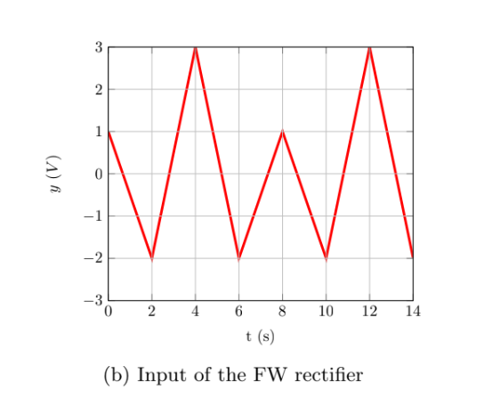

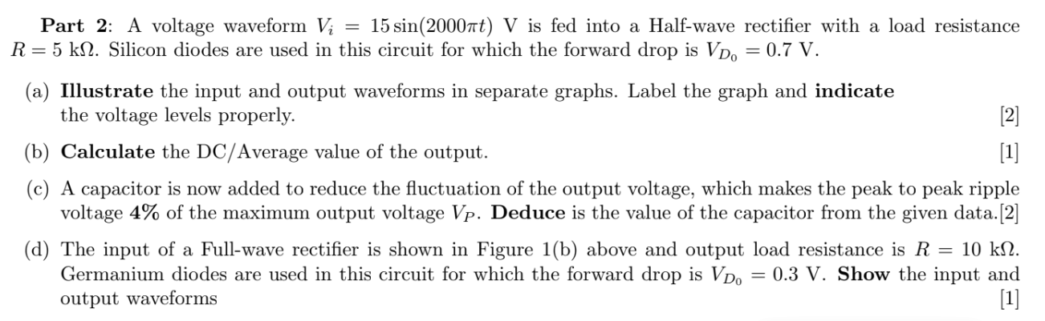

The input of a Half-wave rectifier is exhibited in the Figure above and output load resistance is R = 5 kΩ. Silicon diodes are used in this circuit for which the forward drop is $V_{D0}$ = 0.7 V.
i. Show the input and output waveforms. [3]
ii. Draw the VTC curve [2]
Iii. Calculate input and output frequency [3]
- The input of a full-wave rectifier is exhibited in the Figure above and output load resistance is R = 5 kΩ. Silicon diodes are used in this circuit for which the forward drop is $V_{D0}$ = 0.7 V.
i. Show the input and output waveforms. [3]
ii. Draw the VTC curve [2]
Iii. Calculate input and output frequency [3]
- A full-wave rectifier is designed to deliver a maximum current I_{L} = 120 mA to the load. The rectifier produces an output with a ripple of 5% of the peak output voltage. An input line voltage of 120 V (peak), 50 Hz is available. A 10:1 step-down transformer is used to transform the supply voltage to 12 V (peak).
- Draw the Voltage Transfer Characteristics of the full-wave rectifier. [2]
- Calculate the peak output voltage. [1]
- Determine the value of the Load Resistor to deliver a maximum load current of 120mA. [2]
- Deduce the value of the Capacitor and the DC average value. [1]
- Assume the transformer is removed and the rectifier is directly connected to the AC power supply line. Discuss the state of the diodes. [ Hint: use the Peak Input Value of the rectifier input] [3]

Zener Diode

Q1
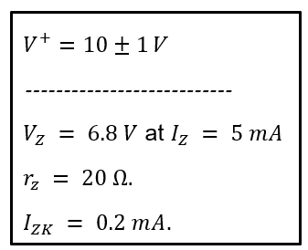
The 6.8-V Zener diode in the circuit of Figure is specified to have the following parameters. The supply voltage $V^{+}$ is nominally 10 V but can vary by ±1 V.
- Find $V_{O}$ with no load and with $V^{+}$ at its nominal value

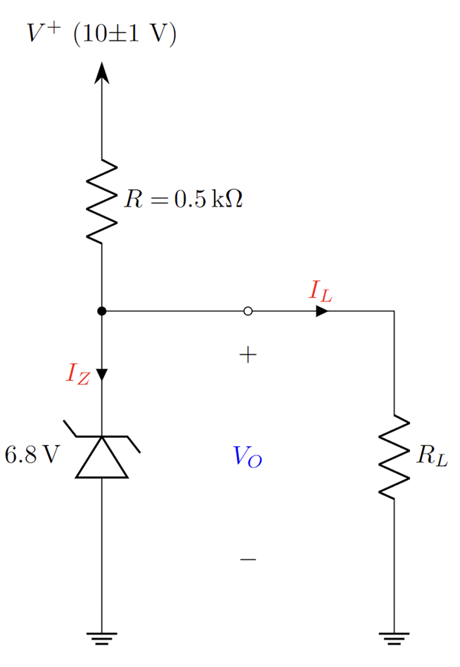
- (For $R_{L}$=0.5 kΩ). Find the $I_{Z}$ In this scenario, calculate the Zener voltage $V_{O}$, load current $I_{L}$ and input current I

- Find the $R_{L}$ that would give rise to worst-case scenario at worst case $V^{+}$. In this worst-case scenario, calculate the Zener voltage $V_{O}$ load current $I_{L}$ and input current $I$

- (For $R_{L}$=2 kΩ). Find the $I_{Z}$ In this scenario, calculate the Zener voltage $V_{O}$, load current $I_{L}$ and input current I

- Design the circuit, i.e., find the minimum value of the input voltage $V^{+}$ such that, voltage regulation is maintained even in the worst-case scenario for $R_{L}$=2 kΩ. (Forget that $V^{+}$ is 10 V)

- Determine whether the circuit will maintain regulation if $V^{+}$ is increased. If yes, argue if it should be increased or not.

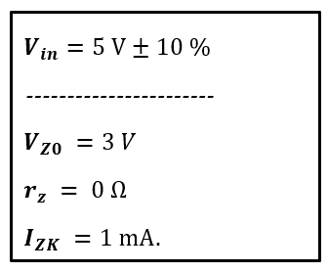
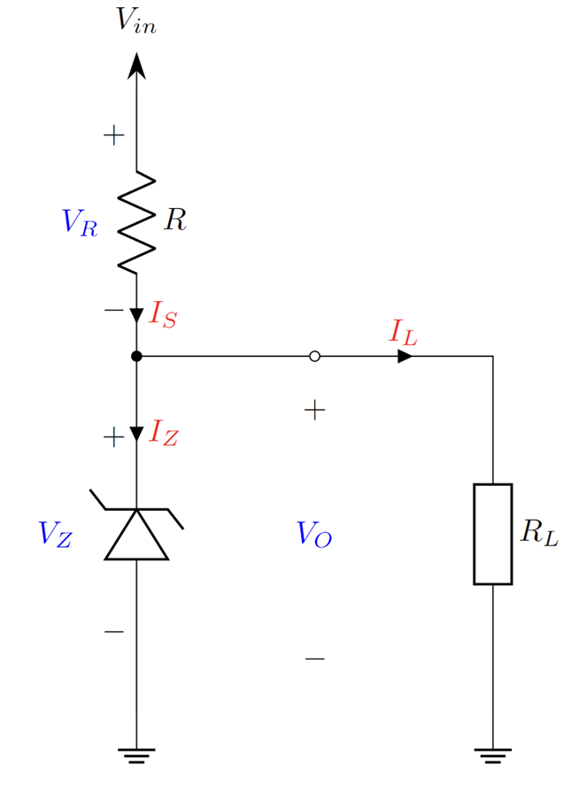
Q2
The Zener diode in the circuit of Figure is specified to have the following parameters. The supply voltage 𝑽_𝒊𝒏 is nominally 𝟓 𝑽 but can vary by ±𝟏𝟎 %. Load current can vary from 𝟎 mA to 𝟓𝟎 mA.

- Find minimum and maximum input Voltage, V_in (min) and V_in (max), maximum and minimum load current I_L (max) and I_L (min), minimum diode current I_Z (min).

- Find the I_Z, V_in and I_L at the worst-case scenario.

- For the worst case what is I_S and V_R.

- Find R for which diode maintains regulation at worst case scenario

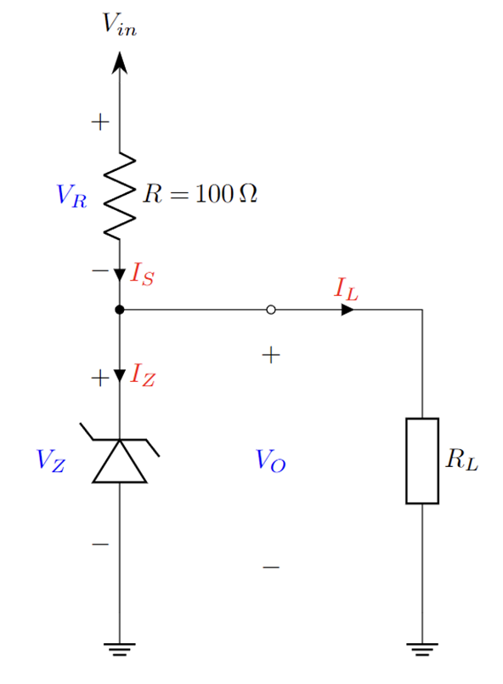
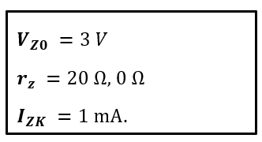
Q3
The Zener diode in the circuit of Figure is specified to have the following parameters.

- Find minimum input voltage, 𝑽_𝒊𝒏 (min) for which the diode maintains regulation, when 𝑹_𝑳=𝟏𝟎 kΩ.

- Find worst case 𝑹_𝑳 if the input voltage 𝑽_𝒊𝒏 is nominally 𝟓 𝑽 but can vary by ±𝟏𝟎 %

BJT

Q1
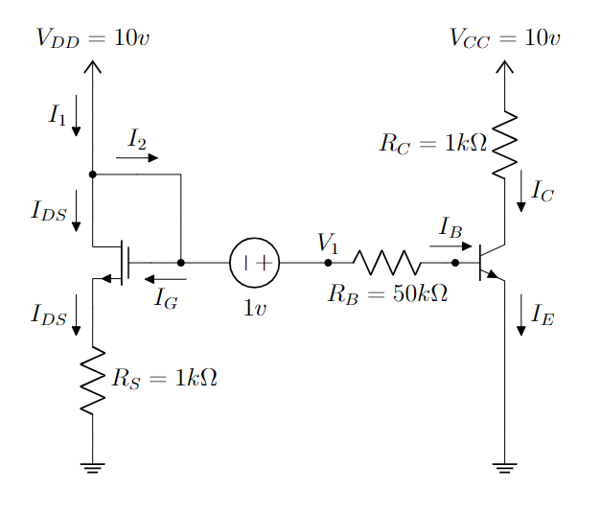
In the circuit above, the MOSFET and BJT have the following parameters,
K = 4 mA/V², V_{T} = 0.9 v, 𝜷 = 100, V_{BE(active)} = 0.7 v, V_{BE(sat)} = 0.8 v

- Find out the gate voltage of the MOSFET.
- Calculate V₁.
- Find out the expression for V_{GS},V_{DS} and V_{OV.}
- Find the operating mode of the MOSFET using the expressions from ©. [Hint: You don’t need any assumption]
- Calculate I_{DS} and V_{DS} using the given parameters.
- Assume that the BJT is in the saturation mode. Now, calculate I_{B}, I_{C}, I_{E}. You must validate the given assumption.

Q2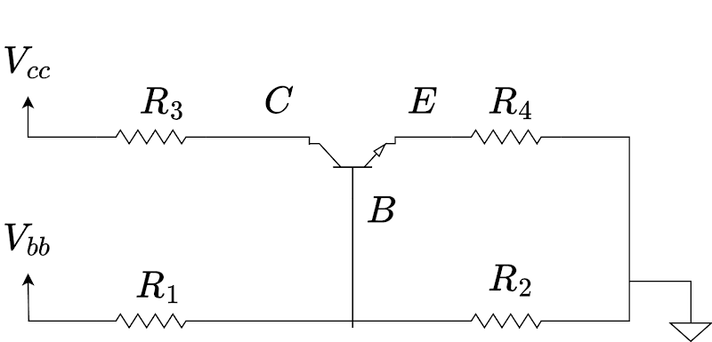
In the above circuit, V_{bb} = 5V, V_{cc} = 15V, R₁ = 20kΩ(40kΩ), R₂ = 80kΩ(60kΩ), R₃ = 2kΩ and R₄ = 1kΩ. Also, assume current gain, Ic/Ib = 100.
a) Draw the equivalent circuit of BJT during saturation and active modes. [2]
b) Solve the above circuit and calculate I_{B}, I_{C}, I_{E}, V_{CE} and V_{C} using the method of assumed states. [Hint: try to find the Thevenin equivalent of the left hand side circuit from the B terminal and ground] [3]
c) If V_{bb} is changed from 5V to 5.1V, what happens to the outputs of the circuits? Calculate I_{B}, I_{C}, I_{E}, V_{CE} and V_{C} again. Now for a 0.1V increase in input V_{bb}, what is the change of I_{c}? Use ΔI_{C} = I_{C,new­} - I_{C,old}. [3+1]
d) Explain any use case of the differences in voltage increase between input and output. What could the use case be to such a phenomenon? [1]

MOSFET

Q1.

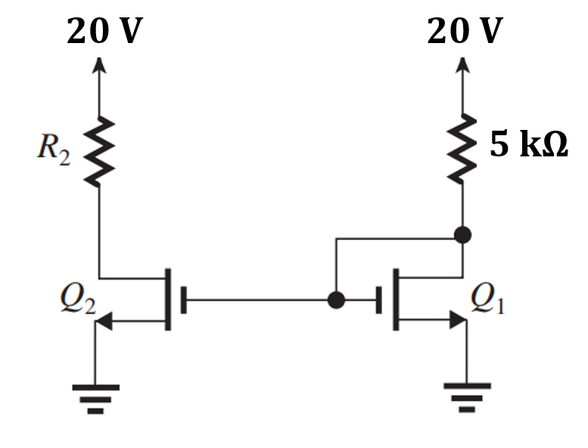
In the circuit above, the MOSFETs have the following parameters, k’n=2 mA/V2, W/L= 2.5, VT=0.5 V.
(a) Find out the operating mode of Q1 [Hint: For Triode mode Vds<Vov and for Saturation Vds>= Vov]
(b) Determine the value of R2 that results in Q2 operating at the edge of the saturation region.
(c ) Calculate the on-state resistance, Ron for Q2. Assume, gate voltage of Q2 is 20 V.
(d) An inverter is designed using Q2 and a 10K resistor. Draw the VTC graph for the inverter.

Q2.
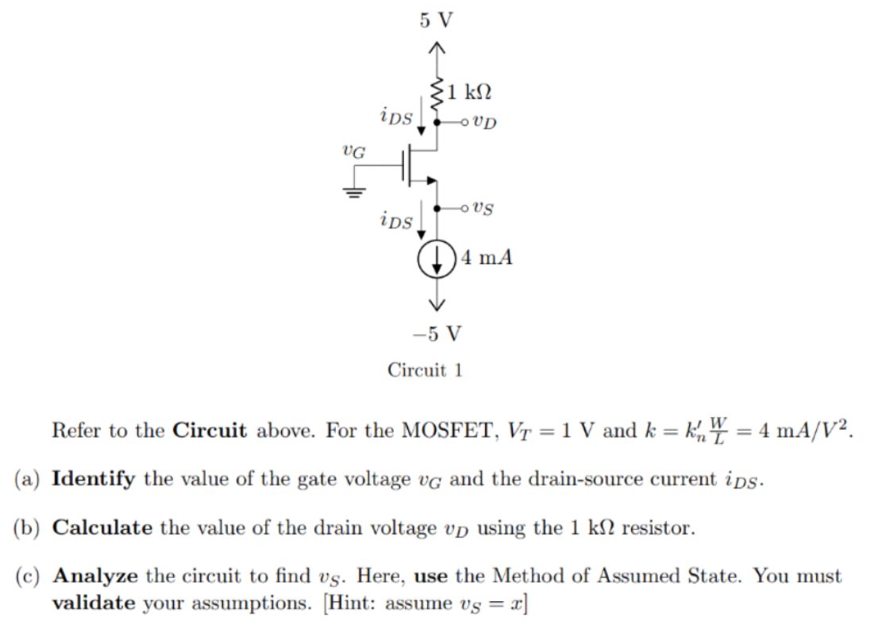

Q3
For the following circuit, find f in terms of boolean input A, B, C, D.
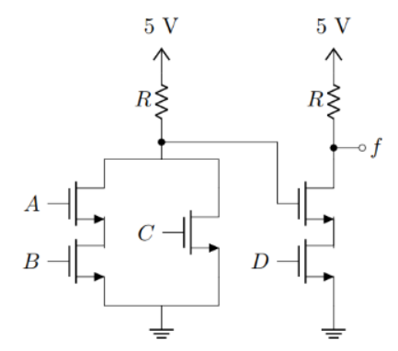

Q4
Use MOSFET to implement the Boolean Logic function, F = $\underline{A\underline{B}+C}$

Q5
I. Draw the VTC of a NOR gate using MOSFET S-model. ii. Draw the VTC of a NOR gate using MOSFET SR-model. Let, Ron= 100 ohms, RL= 10 Kohms, Vss=5 V.

Q6
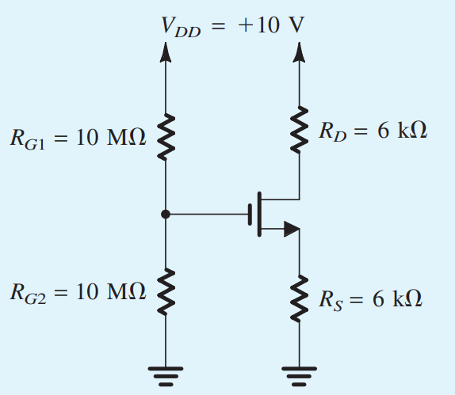

Analyze the circuit to find i_{D} and v_{D} using Method of Assumed State. You must validate your assumptions.
Here, V_{T} = 1v, k = 5 mA/v²

Q7
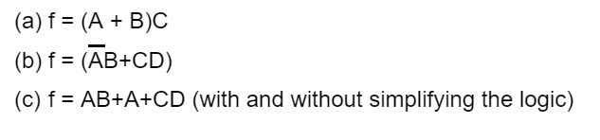

Q8
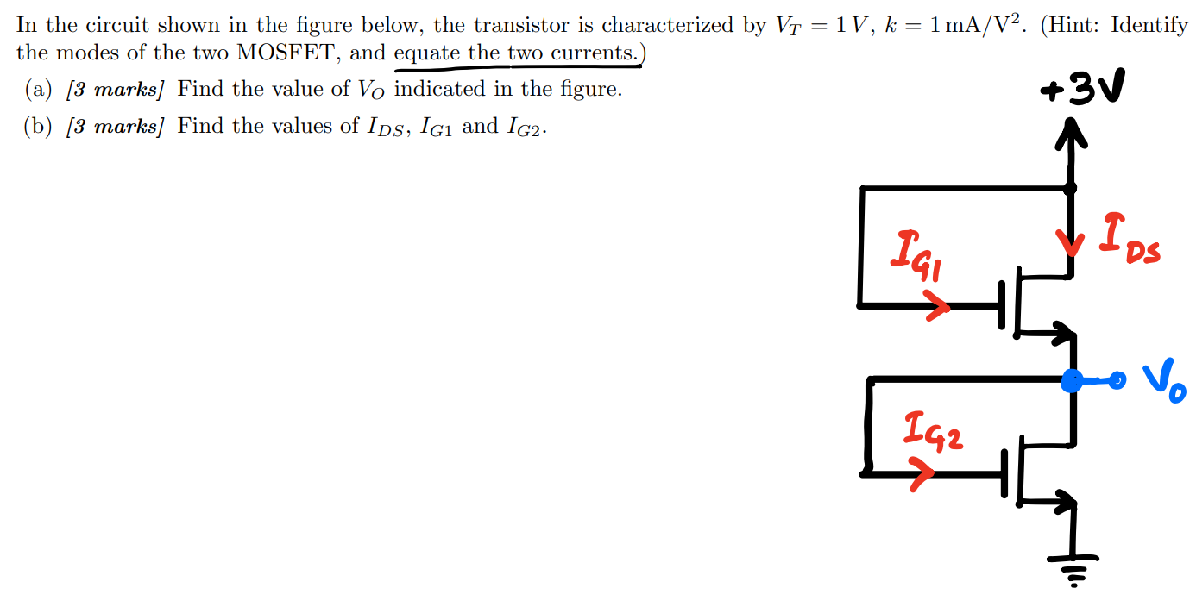

Q9 (1st ckt has too many equations and variables to solve by hand, 2nd ckt can be solved, each mosfet ckt should give you 2 equations in 2 variables with appropriate substitutions, try to solve 2nd ckt to get some practice solving with SR models )

Another hint: SR model is simply the approximate of the MOSFET equation, Id = k(Vov*Vds - Vds^2/2) with Vds^2 negligible, thus giving us, Id = k*Vov*Vds. This should be clear since voltage by current is resistance, and here, Vds / Id = 1 / (k * Vov) = Ron as we learned. So, SR model is a simpler model of MOSFET equation in triode region!
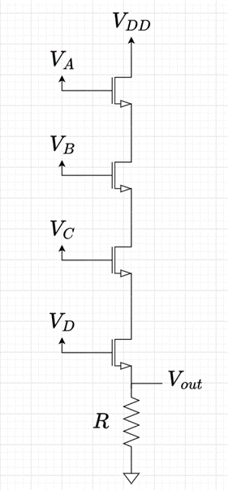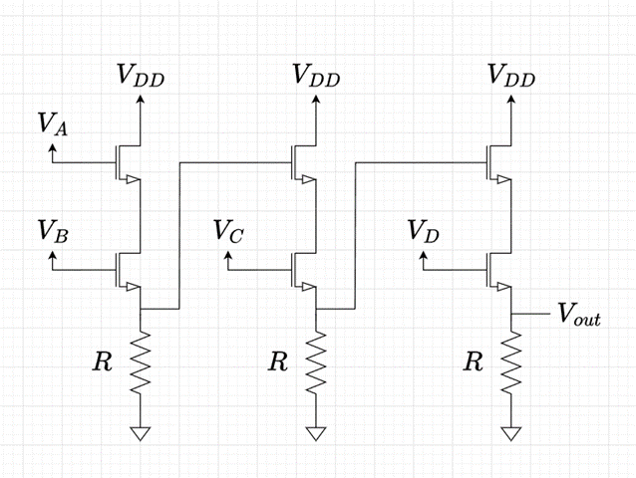
Circuit-1 Circuit-2
The above 2 circuits are implemented for logic gates using n-MOSFETs. All input voltages, VDD, VA, VB, VC and VD are 5V. Given, each n-MOSFET has the following parameters for its SR model: V¬T = 1V, k = 2.5 x 10-4 A/V2 (be wary of units!) and Ron = 1/(kVOV Ω). Also given, VOV = VGS - VT (For this problem, approximate VGS to be equal to VG)
a) Write down the SR model of an n-MOSFET. [1]
b) Find the logic expressions for circuit-1 and circuit-2. [2]
c) Using the SR-model of MOSFET, solve circuit-1 and circuit-2 and find the output voltage, Vout when all inputs, VA, VB, VC and VD are high(+5V). Given, R = 800 Ω. Do the two circuits give the correct output as per their logic expressions? [3]
d) If the outputs of the two circuits are used as gate voltage to a similar n-MOSFET, will it work as intended? That is, will a logical high in output be seen as logical high in the input of any n-MOSFET? If not, what can you do to remedy this. Explain with necessary calculations. [4]

Q10
MOSFET Design
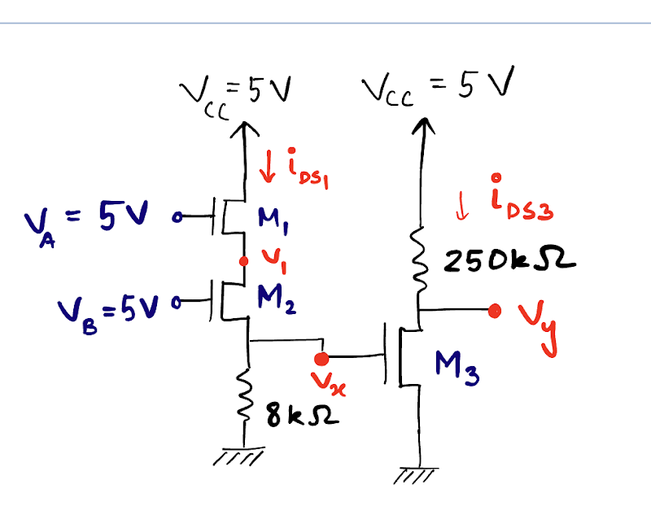
For the following circuit with MOSFETs, assume that =1 V, A/and the aspect ratio W/L is 1 for all the MOSFETS.
- If the gate voltage to M3 MOSFET, V, and MOSFET M2 is in triode mode, find the voltage . [3]
- Find . [2]
- If W/L=2, then = 2.1454 V. Find for this case. [2]
- Can you explain, whether there will be any changes in the output voltage at for W/L = 2 from that in (‘b)’. Also, comment on whether a larger or smaller value of W/L ratio is preferred in this case. [2+1]

For the following circuit with MOSFETs, assume that =1 V, A/and the aspect ratio W/L is 1 for all the MOSFETS.
- If the gate voltage to M3 MOSFET, V, and MOSFET M2 is in triode mode, find the voltage . Verify the modes for both M1 and M2 [3]
- Find . [2]
- If W/L=4, then = 2.04 V. Find for this case. [2]
- Can you explain, whether there will be any changes in the output voltage at for W/L = 4 from that in ‘b)’. Also, comment on whether a larger or smaller value of W/L ratio is preferred in this case. [2+1]

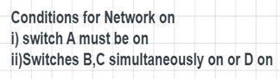
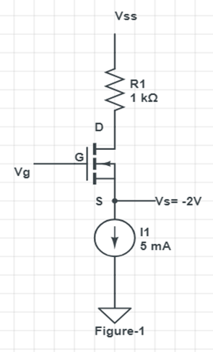
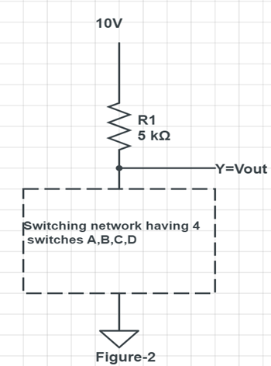
Q11

a)For figure-2, place the switches as nmos devices and write the output logic function Y in terms of A,B,C,D assuming nmos switch model. [ 2]
b)From figure-2, assuming SR model for nmos find the output voltage when only A and D switches are ON( Assume Ron= 0.1 KΩ) [3]
c)For figure-1, k=2 mA/V² , V_{T} =1 V [3+2]
i)Find the gate voltage so that the mosfet is in saturation mode.
ii) Then find the minimum supply voltage Vss to operate the device in this
condition. [Hints , V_{ov}=V_{DS}]
d)Bonus - from figure-2 is it possible to drive a not gate cascaded to Vout ?
[V_{T} =0.5V, Vout(low)=Vout of question(b)] [2]

Q12 (MOSFET+Diode)
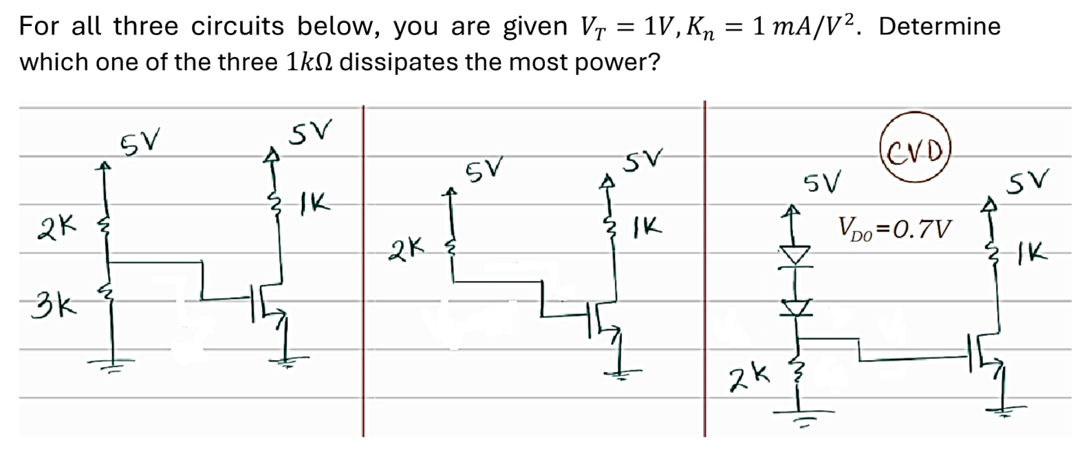

Q13
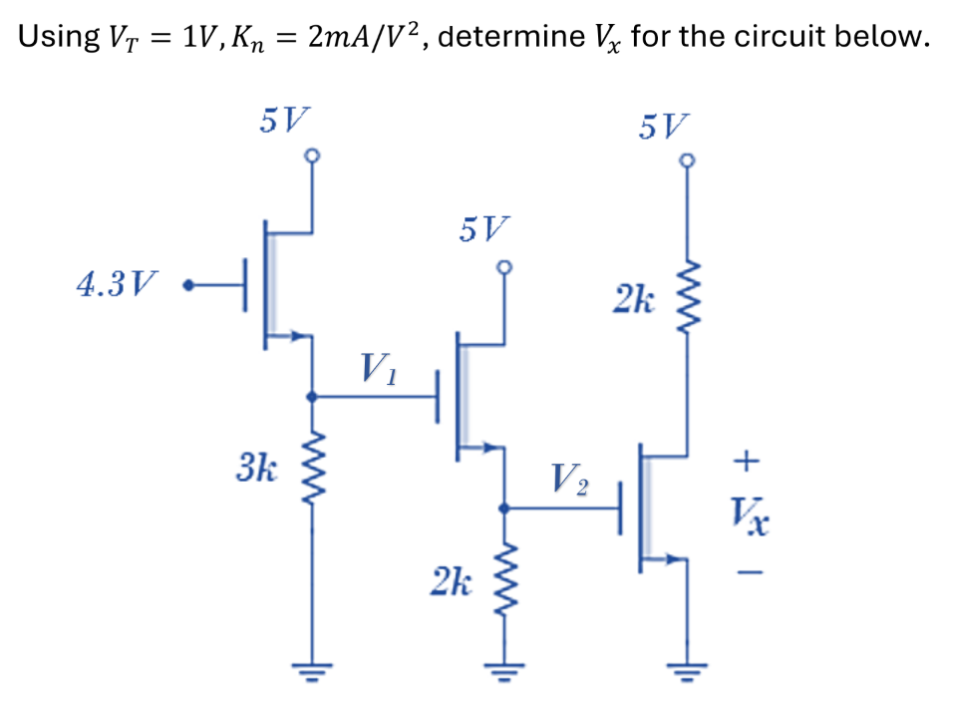

Q14 (MOSFET+Diode)
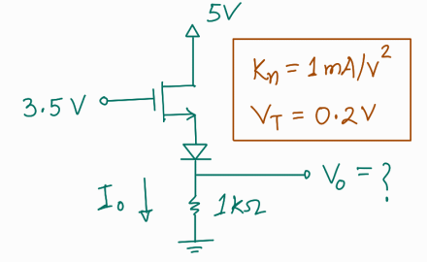

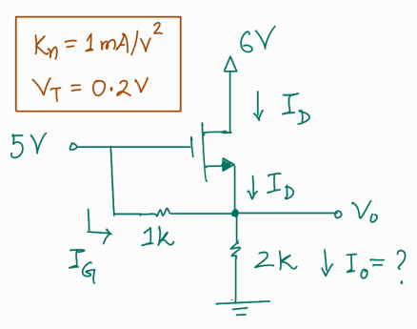
Q15

Q16

You are given (i) E=2, or, (ii) E=5. Determine the operation modes of the M1 and M2 MOSFETs. Also, find the power dissipated in the 2kΩ resistor.

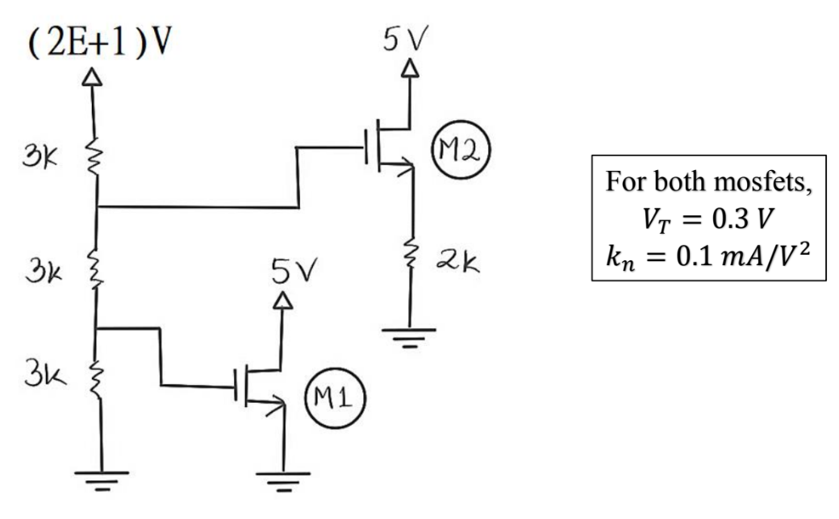

Hybrid

Q1 [MOSFET, Zener]

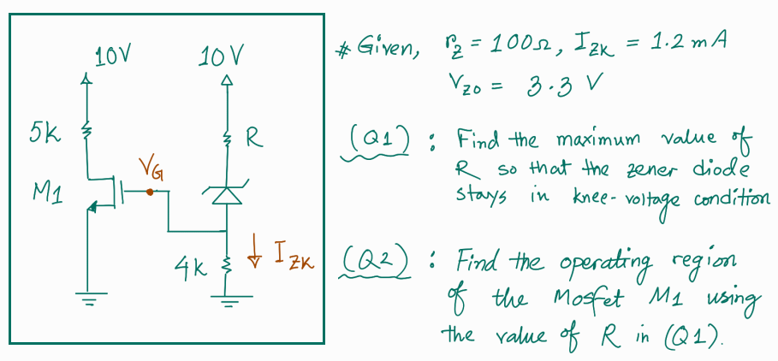
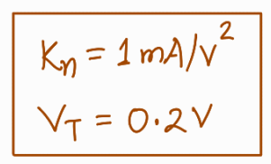

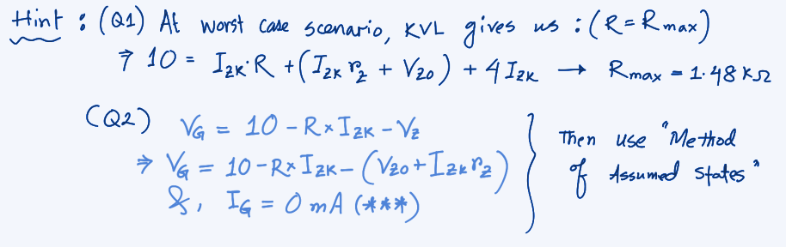

Q2 [MOSFET,BJT]

